ITI Examination System

**Implemented by**

*Diaa Ahmed Refat*

*Abdelrahman Mohamed Raafat Ahmed*

*Khaled Hassan Zakaria Shaaban*

**Graduation Project**

**Intensive Code Camps Power Bi Development**

**Round 47 Documentation**

## Motivation:

The primary motivation for this project is to **construct an automated system capable of performing online exams**. A core driver is to build a robust SQL

database that empowers **ITI staff with critical reports** for data-driven decision- making.

The key requirements are:

* + - Automating the exam process, including generation, answers, and correction.
    - Providing reports on student information by department , student grades by ID , and instructor course loads.
    - Allowing for detailed analysis of exam content and student-specific answers.

This project leverages a full Business Intelligence stack, including a DWH, SSRS, and **Power BI**, to transform operational data into actionable insights and

visualizations.

## problem definition:

The core problem is the absence of a centralized, **automated system to conduct online exams**. This manual or non-integrated approach creates significant

operational and analytical challenges. Key issues include:

* + - The lack of an automated workflow for **exam generation, answering, and correction**.
    - The inability for ITI staff to efficiently retrieve critical data. There is no system in place to generate essential reports, such as:
      * Student information based on a specific department.
      * The grades of a specific student in all their courses.
      * A list of courses taught by an instructor and the number of students in each.
      * The specific topics covered within a course.
      * Detailed exam breakdowns, including questions, choices , and a comparison of a student's answers.

This "data gap" prevents staff from performing effective academic monitoring and analysis, hindering their ability to make informed, data-driven decisions.

## project objective:

The primary objective is to **construct an automated system that can perform online exams**, supported by a robust SQL database.

Specific objectives include:

* + - **Automate the examination process**, including exam generation, answers, and correction.
    - **Build a database infrastructure**, consisting of an OLTP database for transactions and a DWH for analytics.
    - **Enable BI & Reporting** for ITI staff to generate key reports (e.g., student grades , instructor course loads ).
    - **Utilize BI tools** like Power BI and SSRS for visualizations and dashboards.
    - **Deliver a Web Application** as the final system interface.

## Gannt chart:

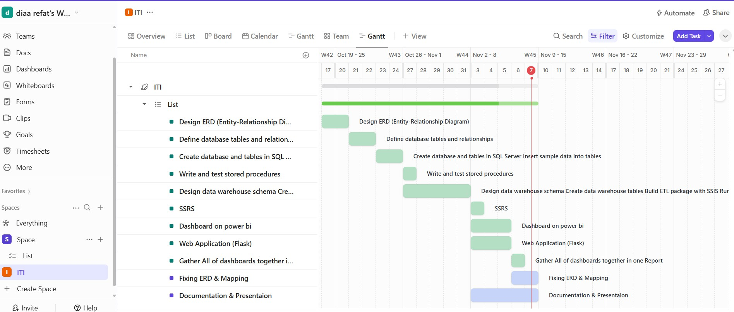

* 1. **Project Development Methodology**

This project followed a **Waterfall Model**, a linear and sequential development approach. This methodology was chosen because the project requirements were clearly defined from the outset, allowing each phase to be completed fully before moving to the next.

The project's lifecycle was divided into the following distinct phases:

#### Requirements Gathering & Analysis Phase

This initial phase focused on defining the exact project deliverables and functional needs.

* + **Core Objective:** The primary goal was established: to **construct an automated system that can perform online exams**.
  + **Key Deliverables:** A clear list of deliverables was required, including an **ERD**, a **Database Dictionary**, **Database Backup** procedures. (Note: a Web Application was ultimately delivered as per our discussion).
  + **BI & Reporting Requirements:** A specific set of six mandatory reports for ITI staff was defined, including:
    1. Student information by Department No.
    2. Student grades in all courses, based on Student ID.
    3. Courses taught by an instructor and student counts, based on Instructor ID.
    4. Course topics, based on Course ID.
    5. Exam questions and choices, based on Exam number.
    6. Exam questions and a specific student's answers, based on Exam and Student ID.
  + **Technology Stack:** The requirements explicitly suggested the use of **Stored Procedures** , **SSRS**, and **Power BI**.

#### System and Database Design Phase

Based on the defined requirements, the full system architecture was designed

*Core Entities:*

|  |  |  |
| --- | --- | --- |
| **Entity** | **Purpose** | **Primary Key** |
| Person | Master entity for all users | ID |
| Student | Student profiles | S_ID |
| Instructor | Instructor profiles | I_ID |
| Manager | Manager profiles | M_ID |
| Course | Course definitions | Course_ID |
| Exam | Exam instances | Exam_ID |
| Question | Test questions | Quest_ID |
| Choice | Multiple choice options | Choice_ID |

* **OLTP Database Schema:** The transactional database,

ITI_Examination_System , was designed to handle all daily operations.

### ERD

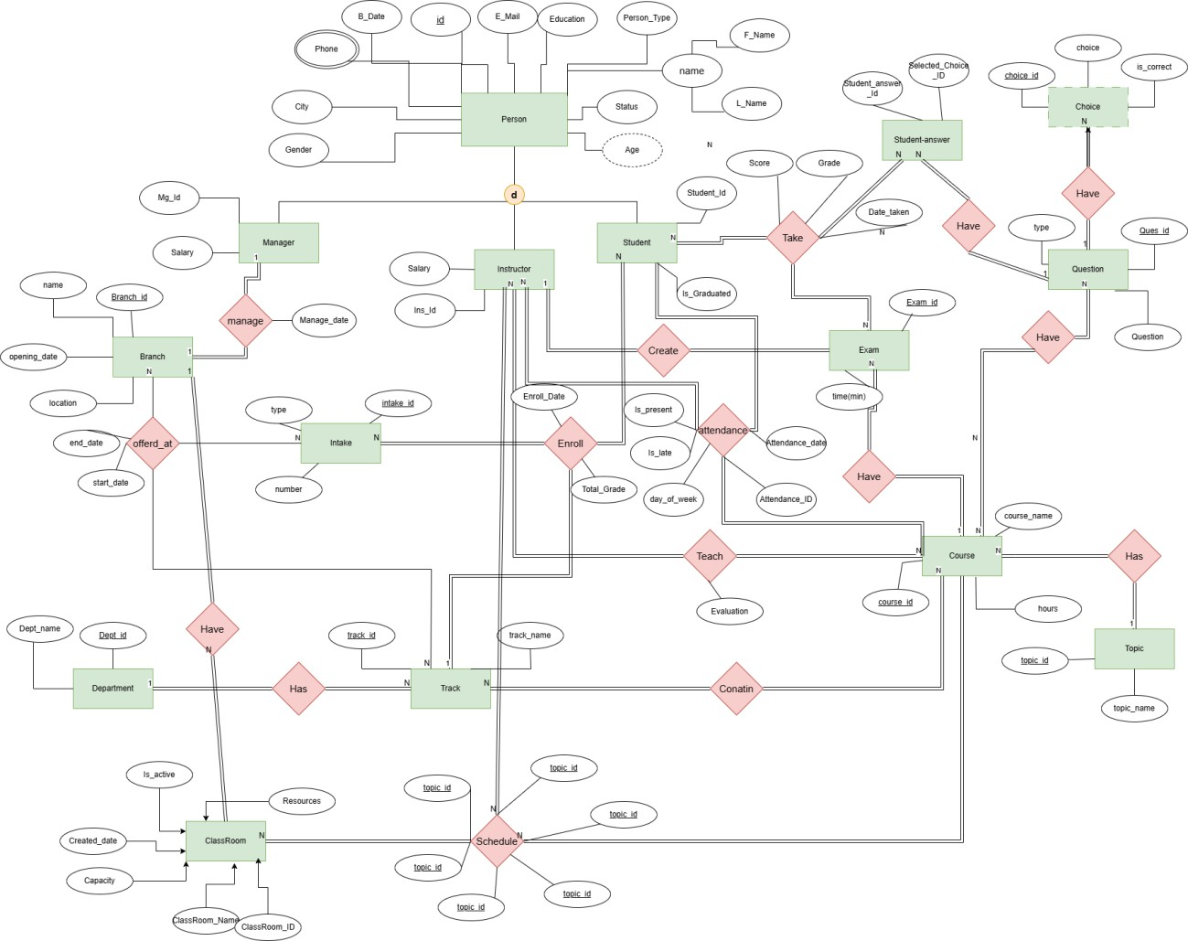

* + 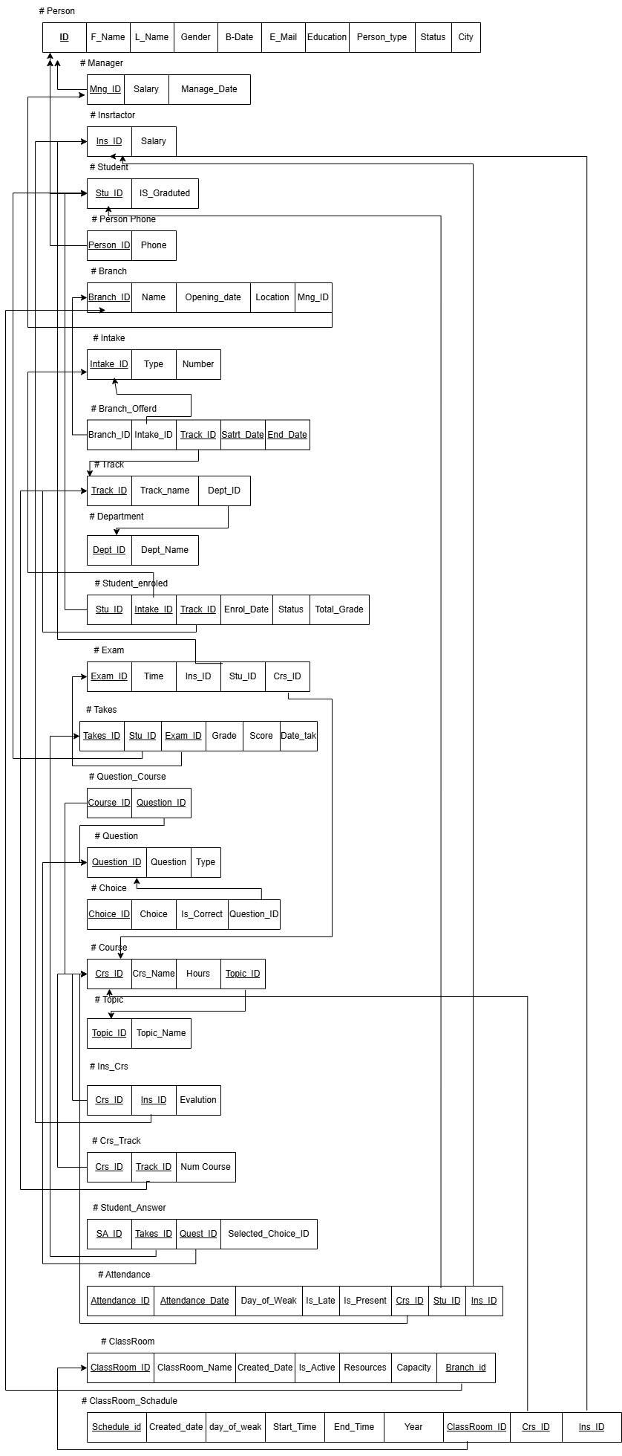Mapping
* **DWH Database Schema:** The dimensional database, ITI_Examination_System_DWH , was designed using a **Galaxy Schema**. This included dimension tables (e.g., Dim_Student, Dim_Course, Dim_Date) and fact tables (e.g., Fact_Exam_Performance, Fact_Attendance) for analysis.

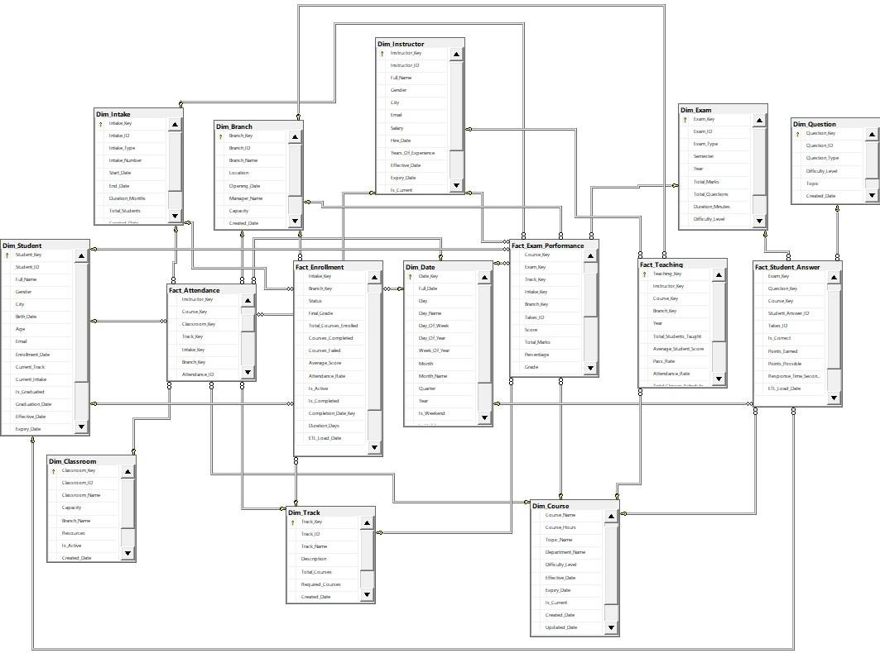

1. **Implementation Phase**

This phase involved the development of all components as designed.

**Database Build:** The SQL scripts were executed to create the databases and all their objects (tables, constraints, etc.).

**Data Generation:** To populate the database for analysis and testing, a large, realistic dataset was required. This was a time-consuming process, so **AI Development Assistants** were used to accelerate the generation of mock data that followed the defined business rules and database schemas. This was essential for effectively testing the SSRS reports and Power BI dashboards.

**Stored Procedure Development:** A large number of stored procedures were coded to:

### Handle all CRUD operations

1. Fulfill the eight specific reporting requirements for ITI staff.
2. Core functionalities for **Exam generation**, **Exam Answers**, and

**Exam Correction** were implemented.

* Handle all CRUD operations (e.g., INSERT_NEW_STUDENT, UPDATE_INSTRUCTOR, sp_Delete_Exam).

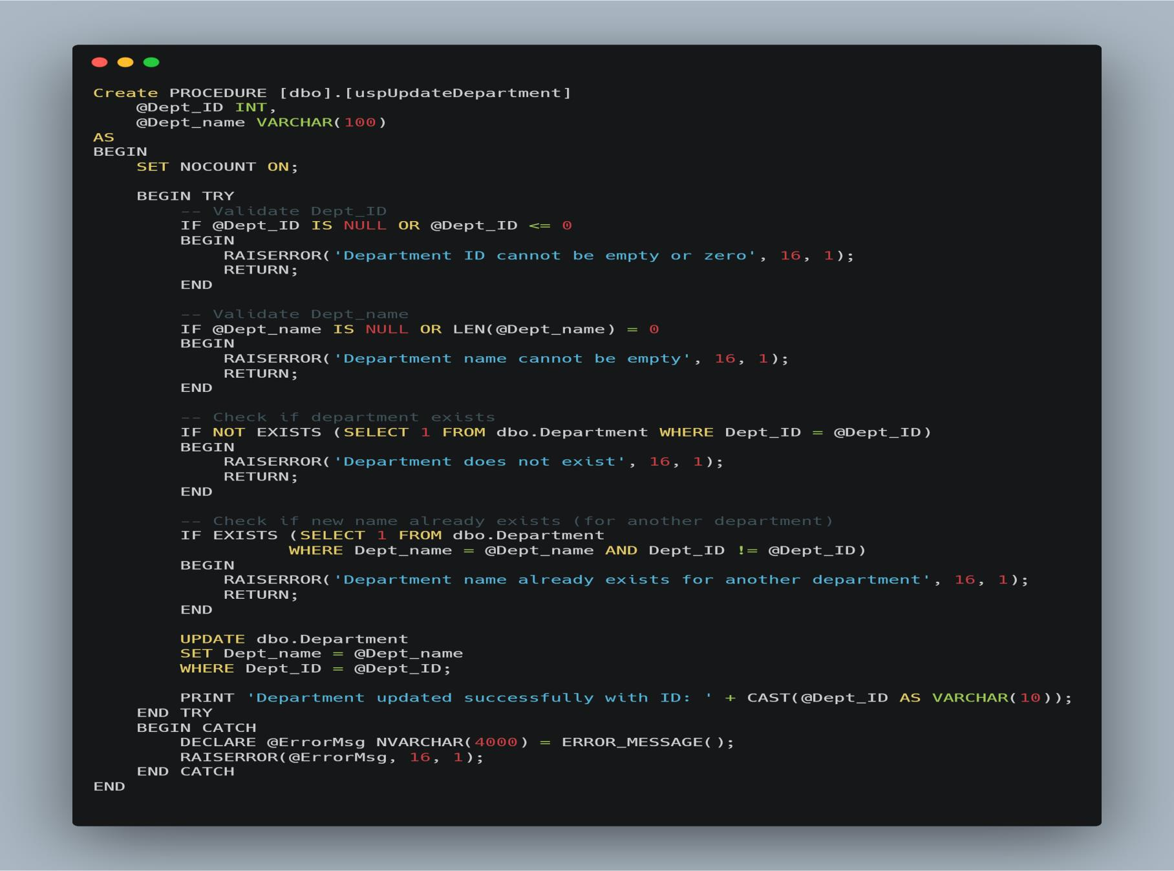

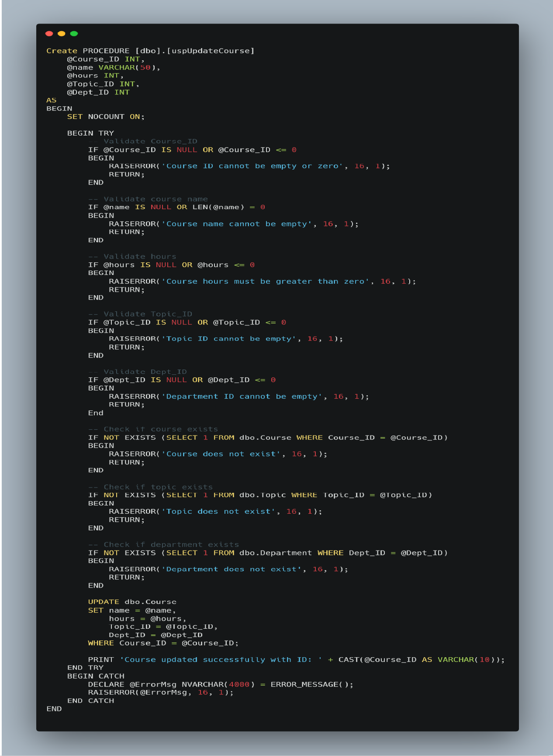

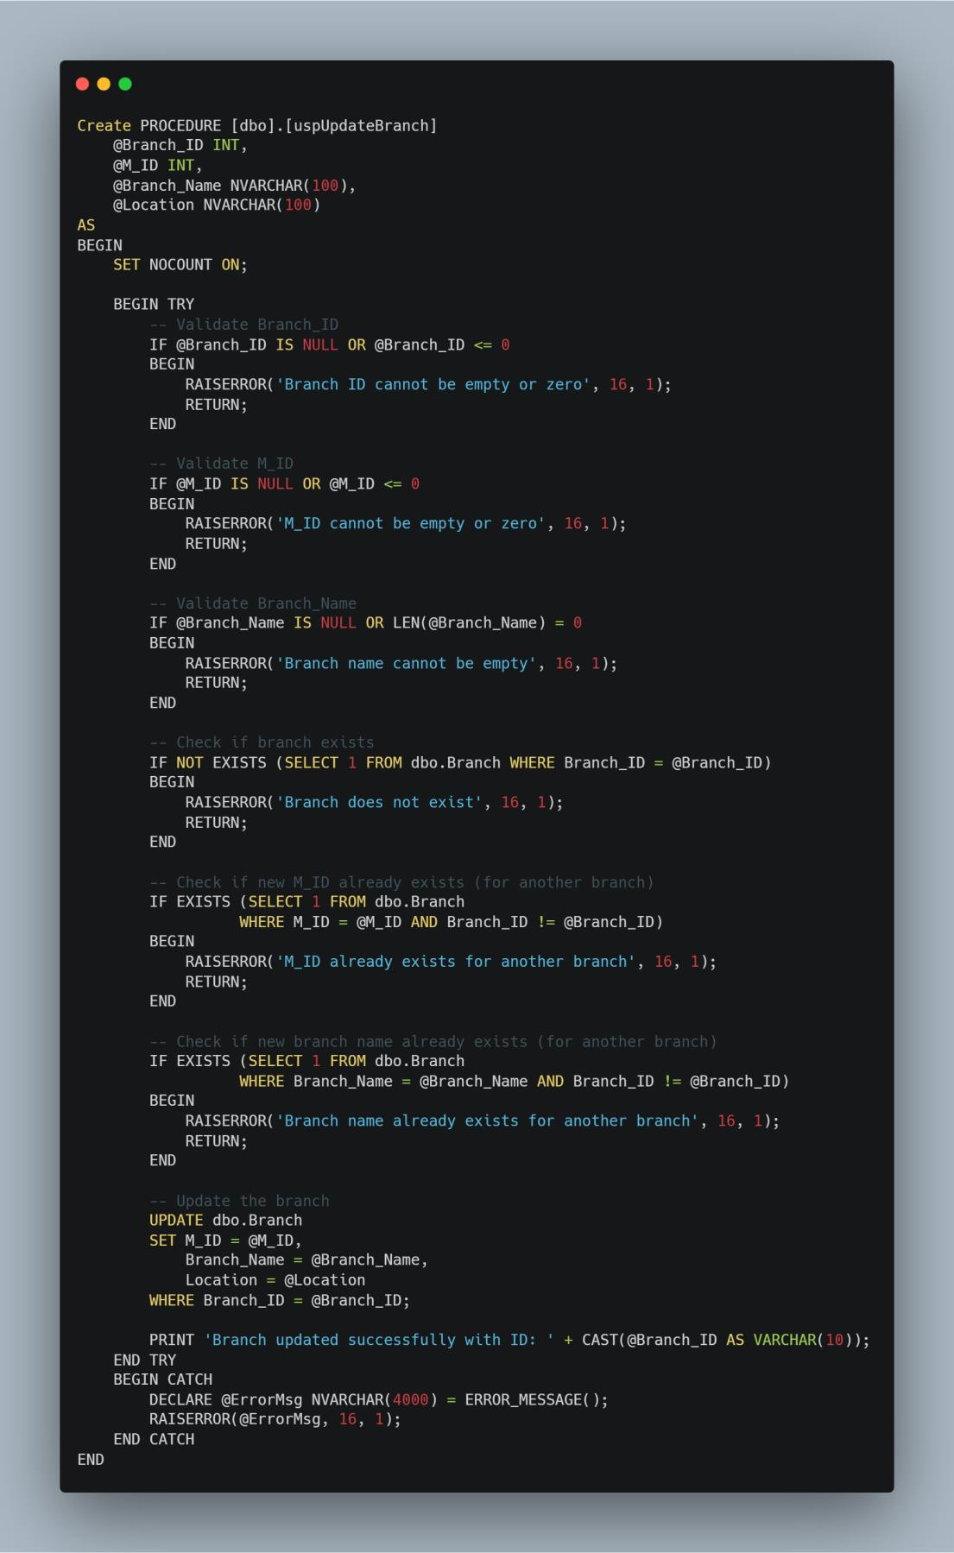

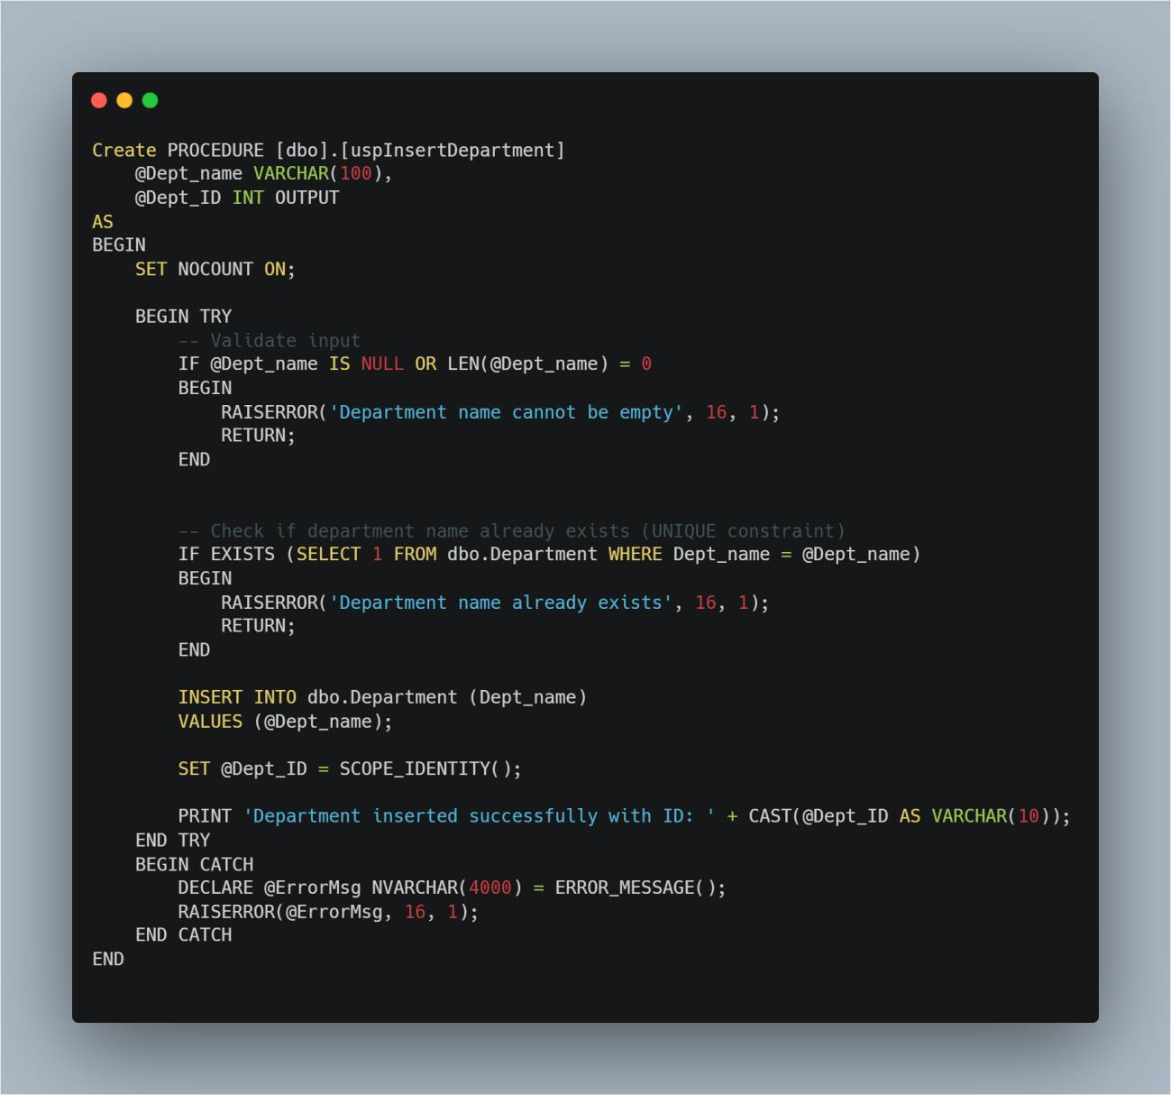

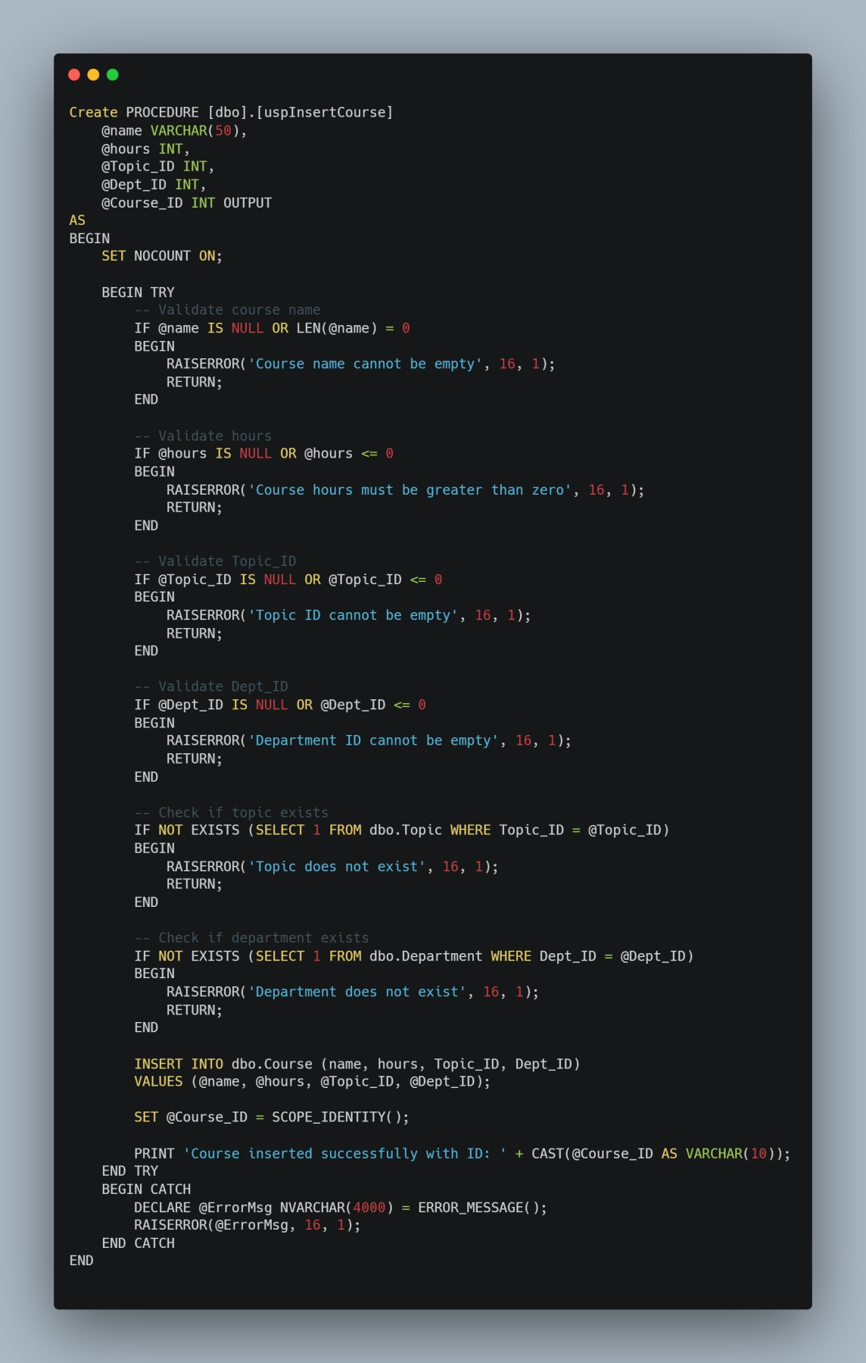

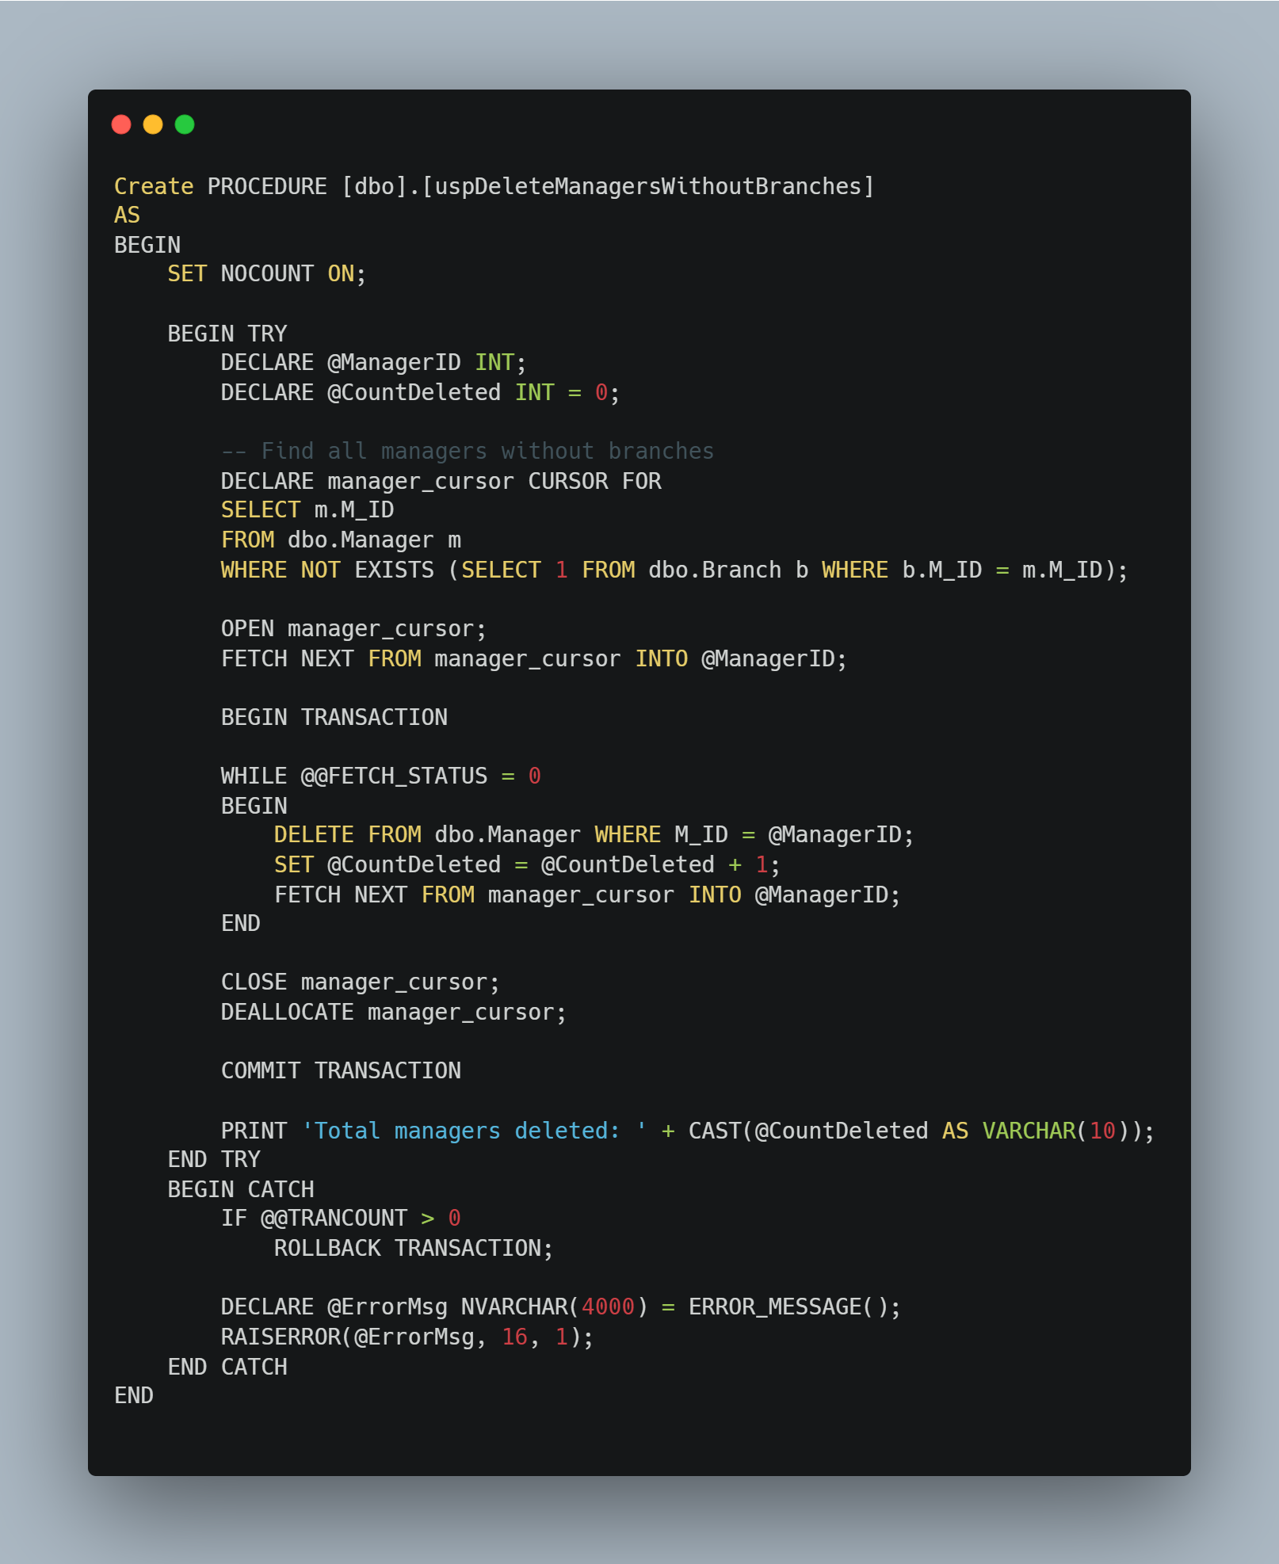

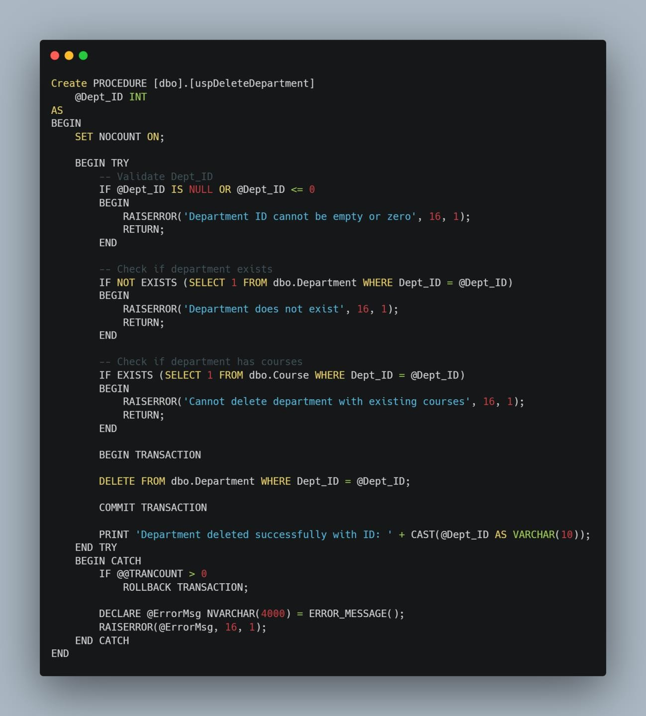

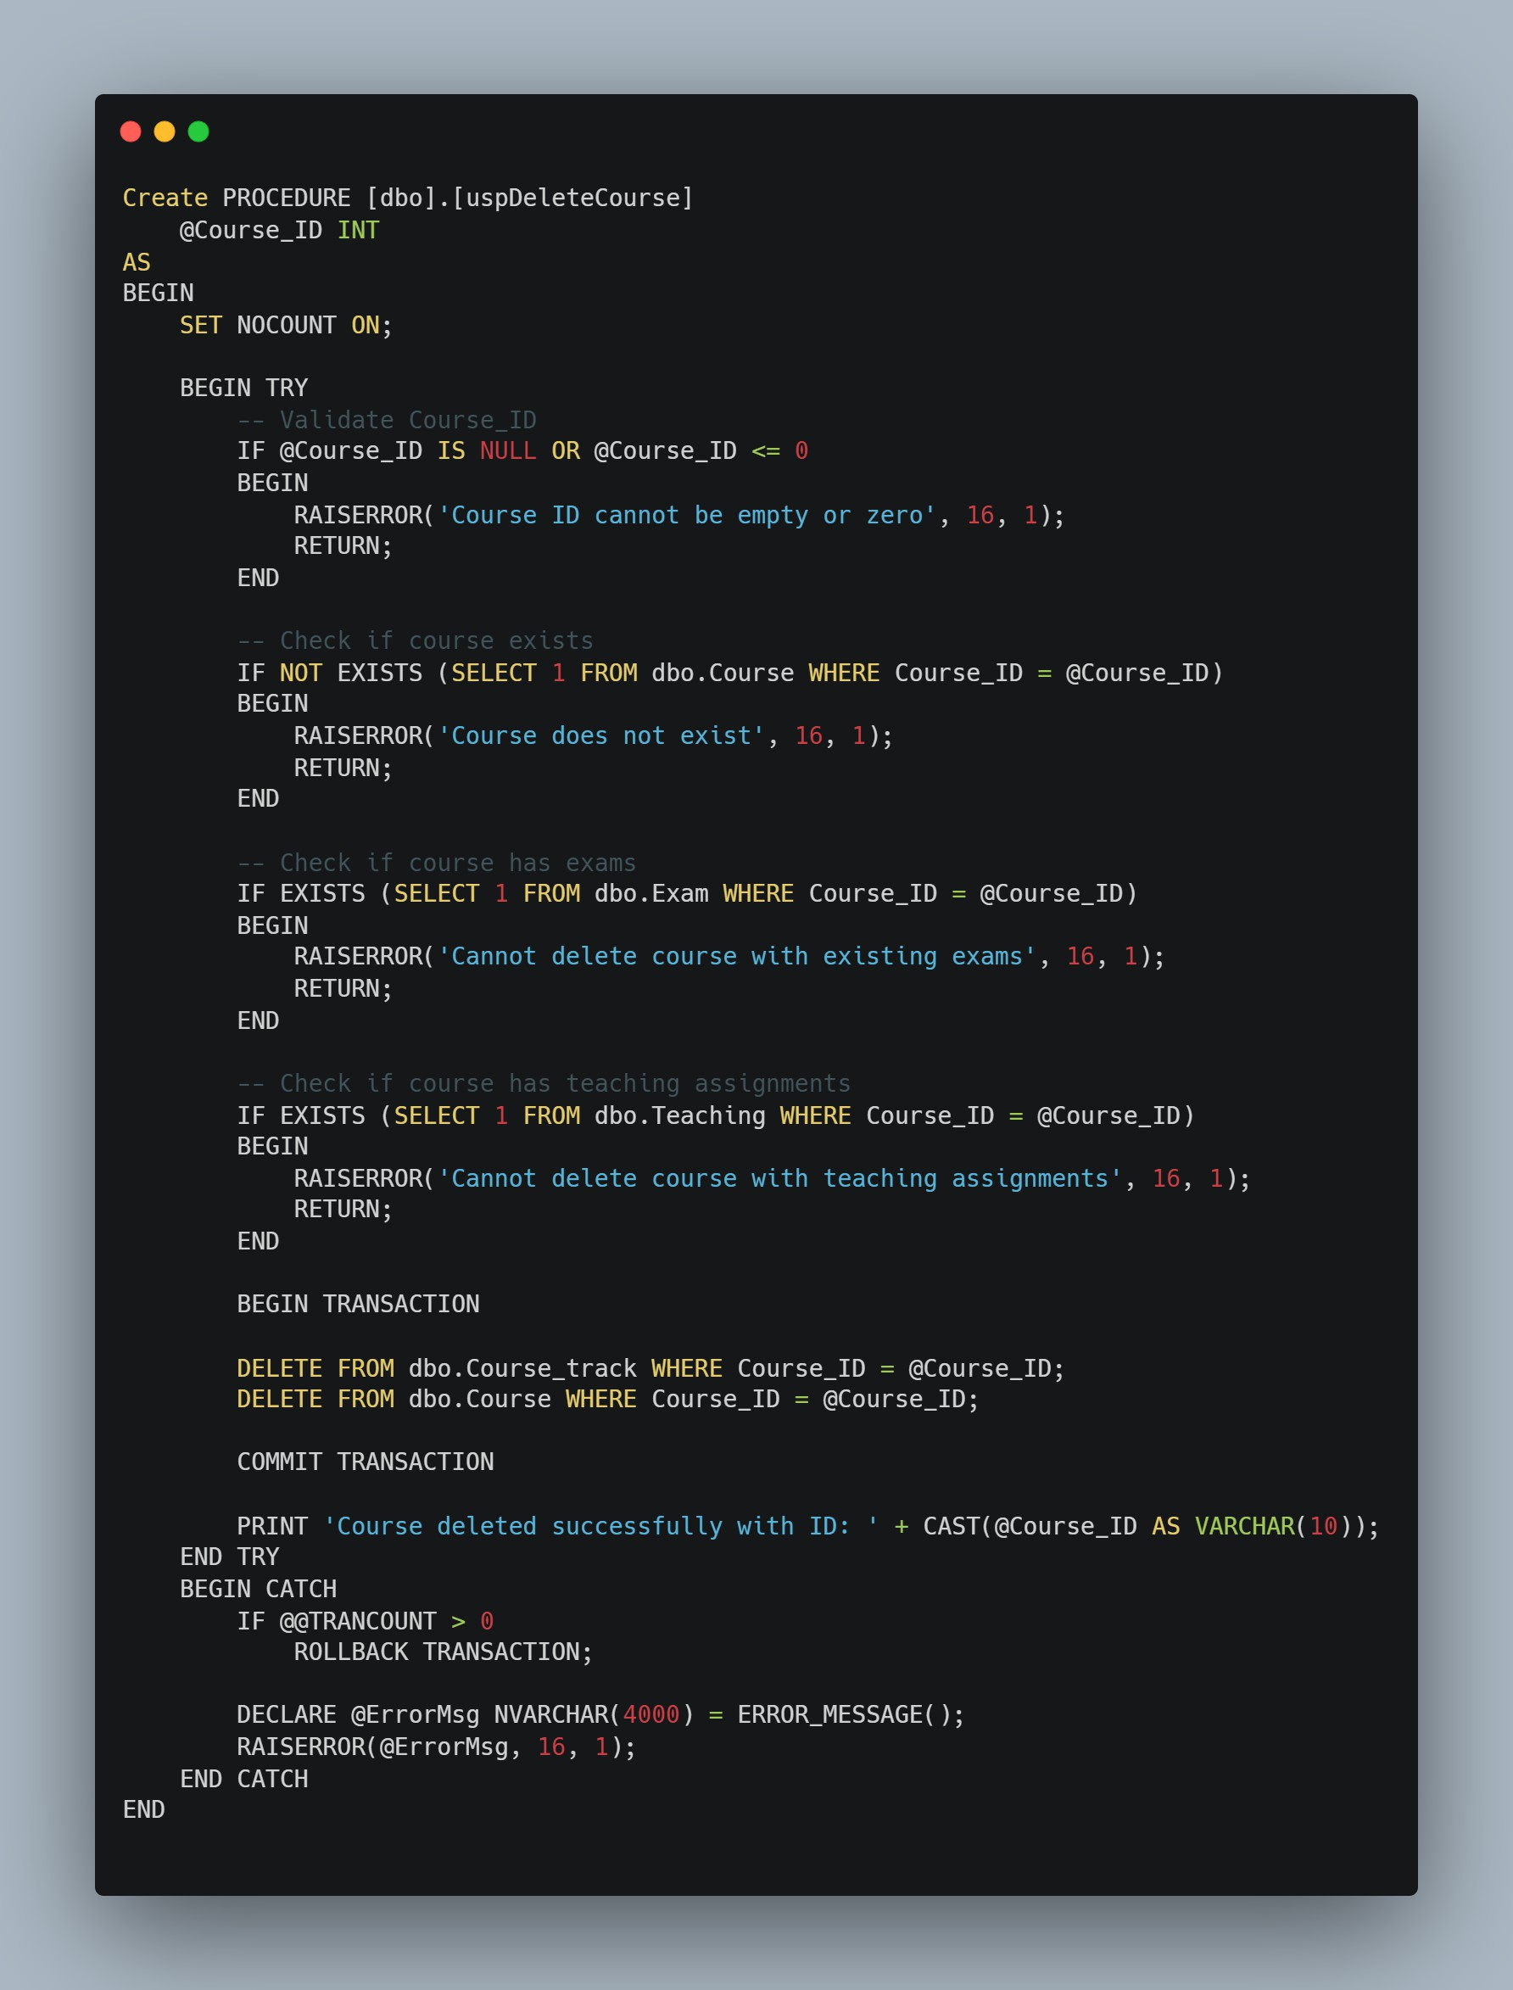

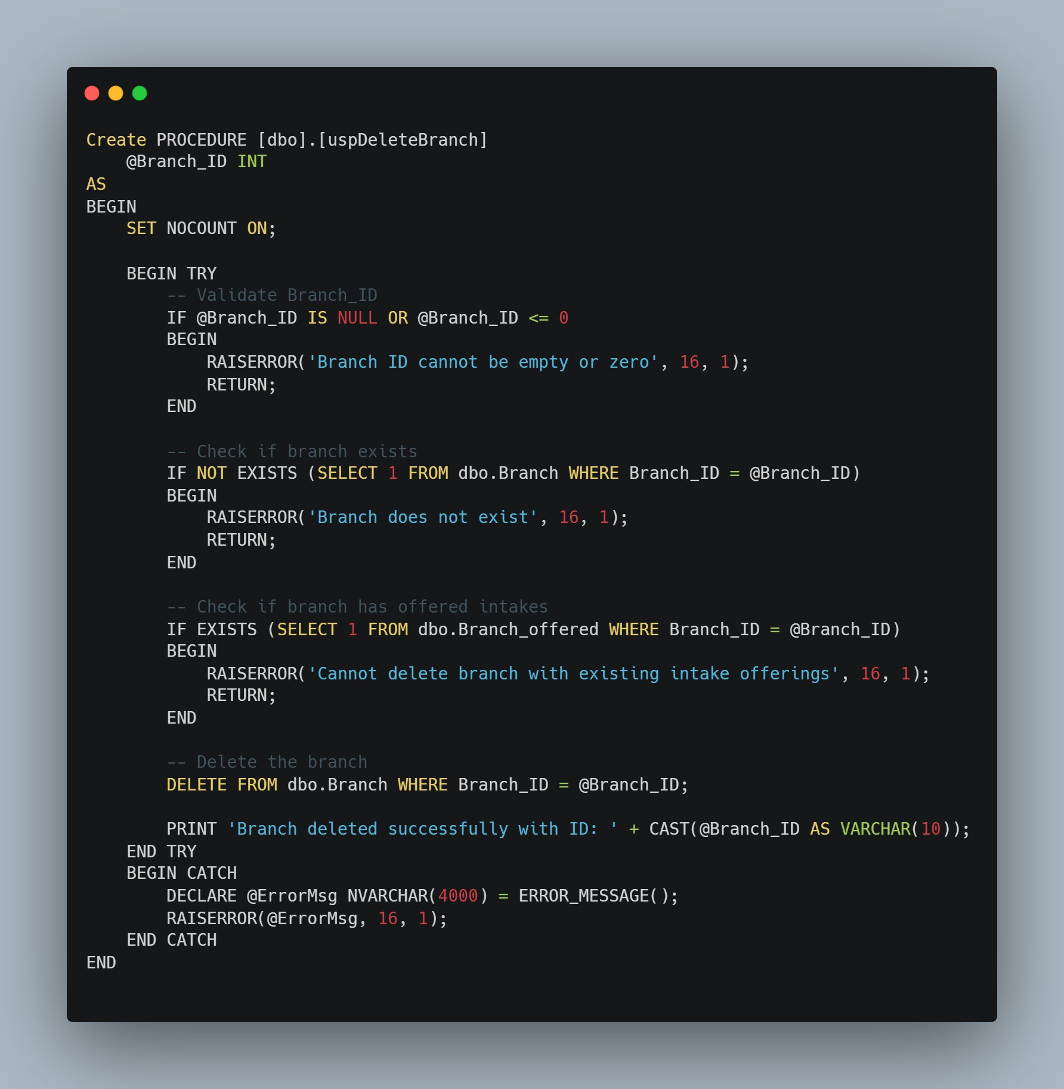

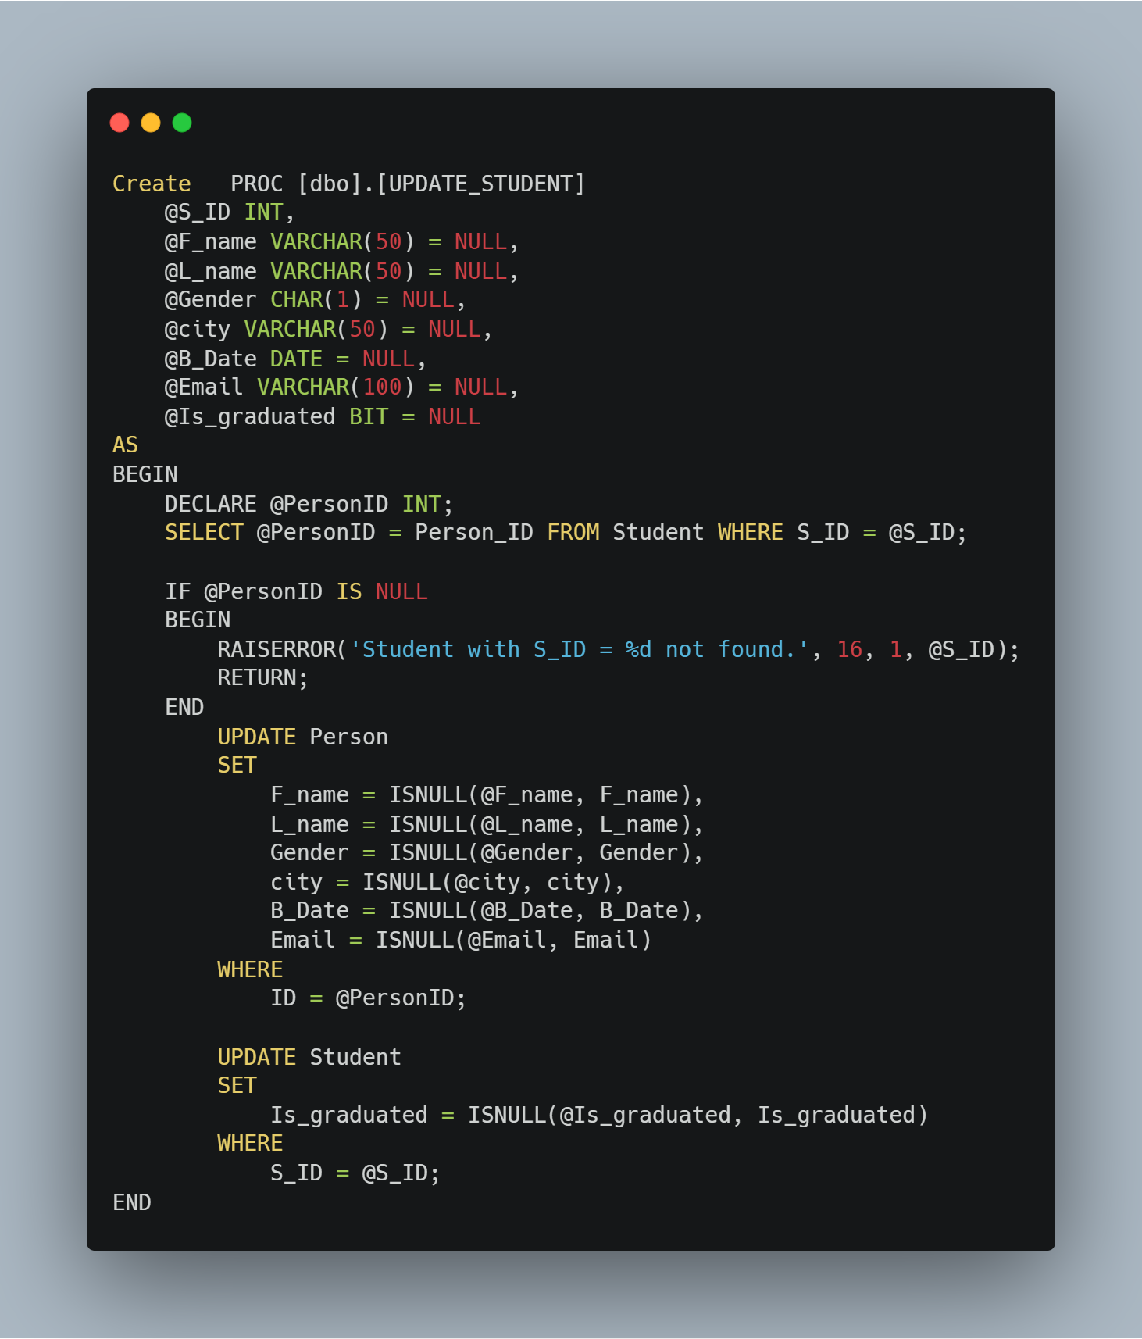

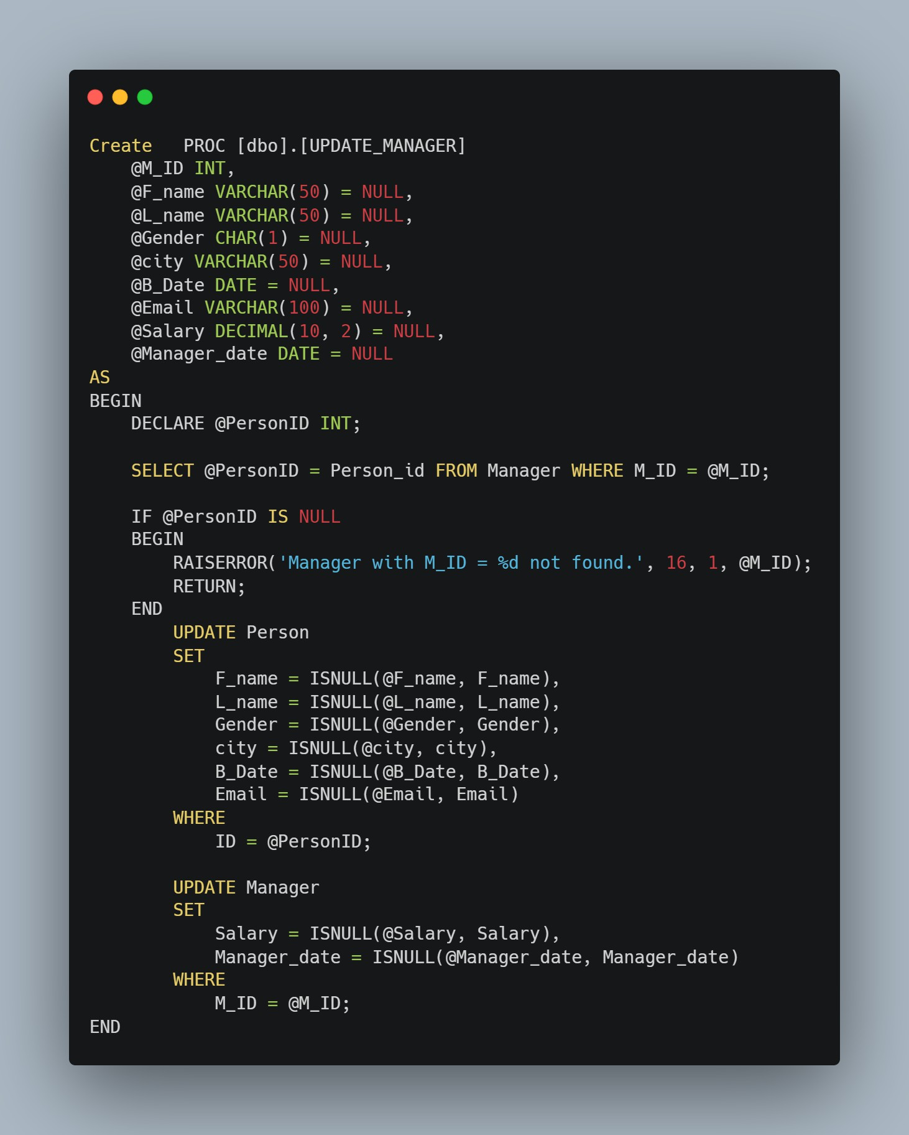

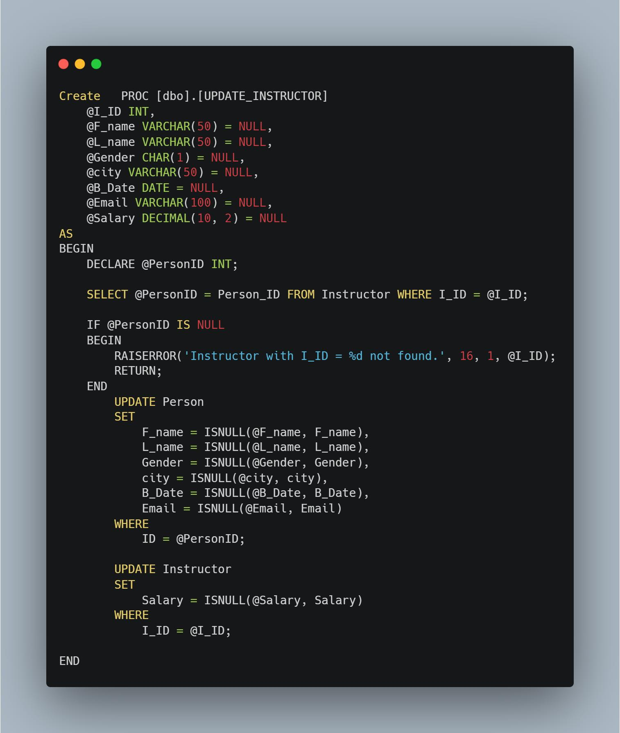

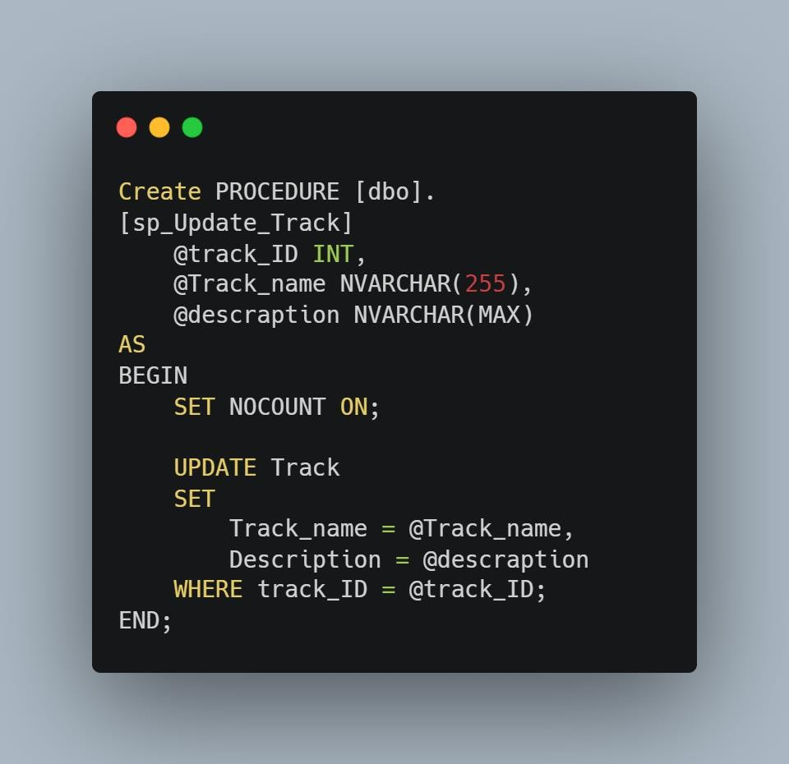

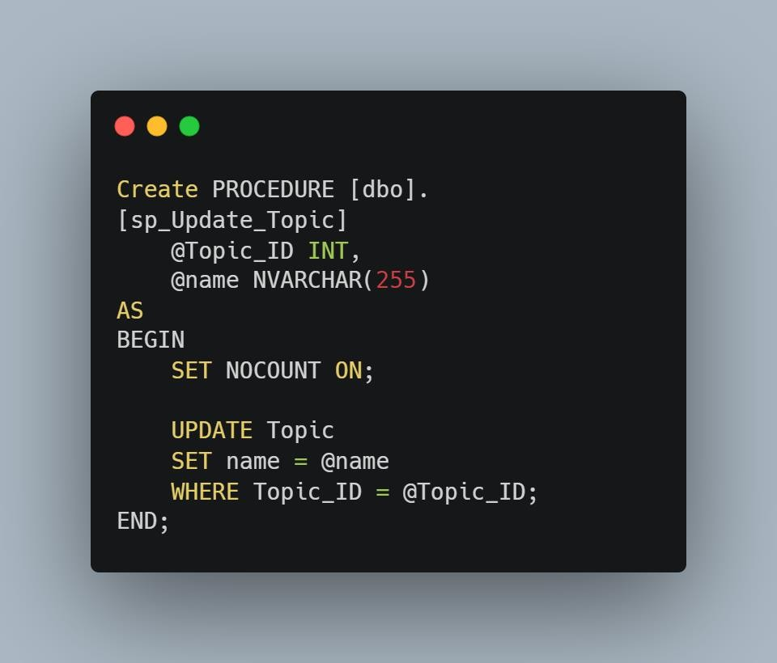

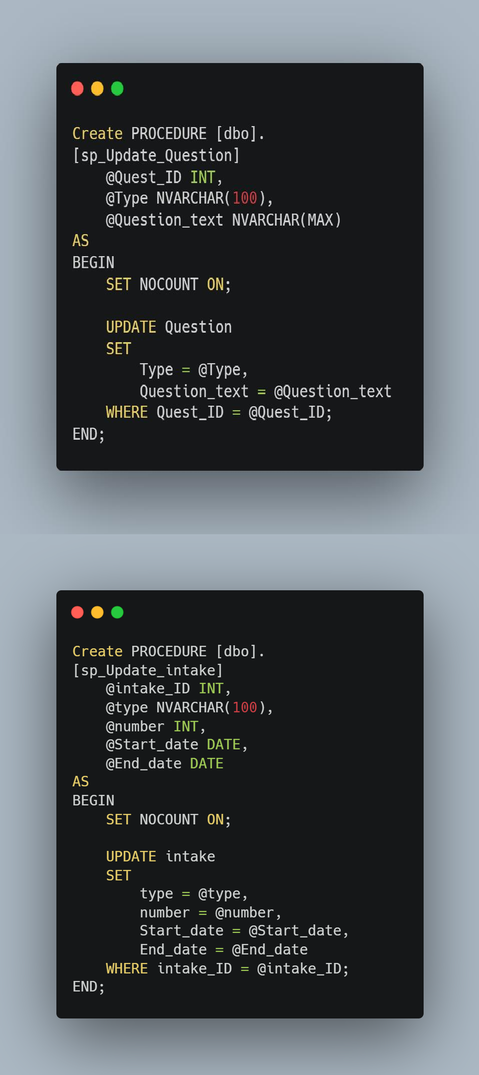

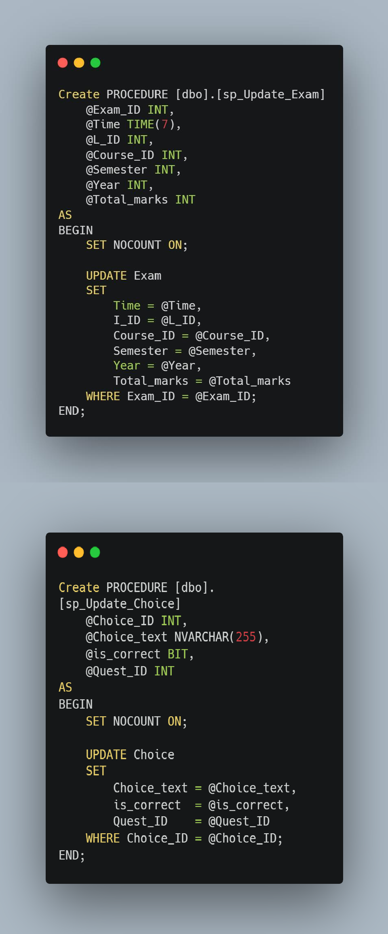

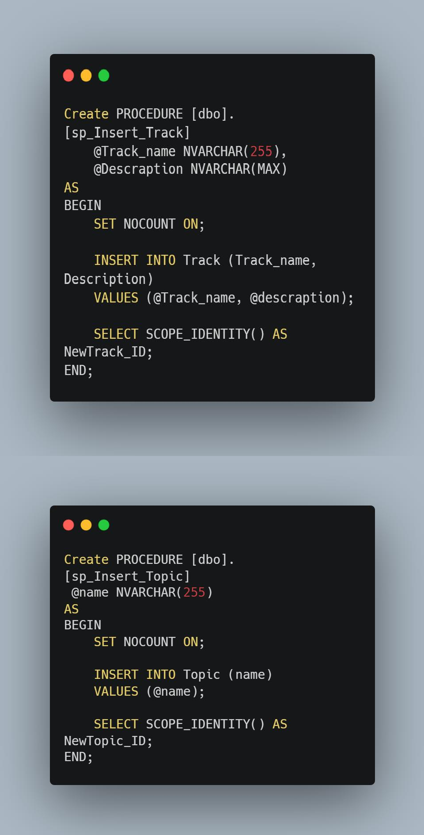

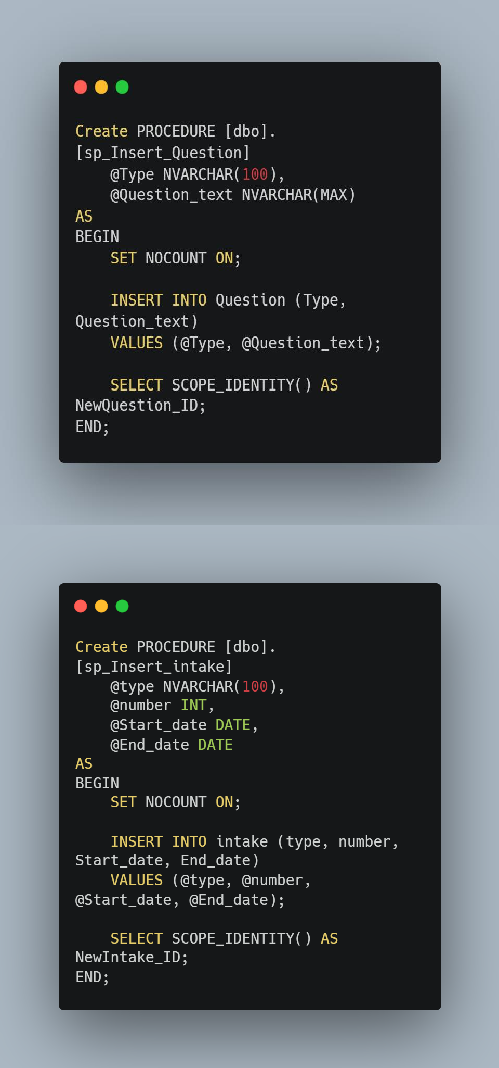

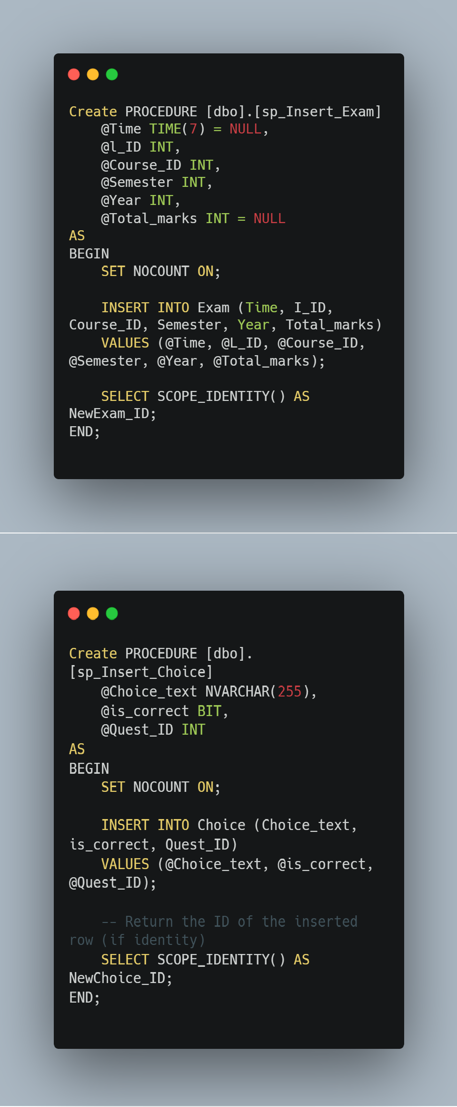

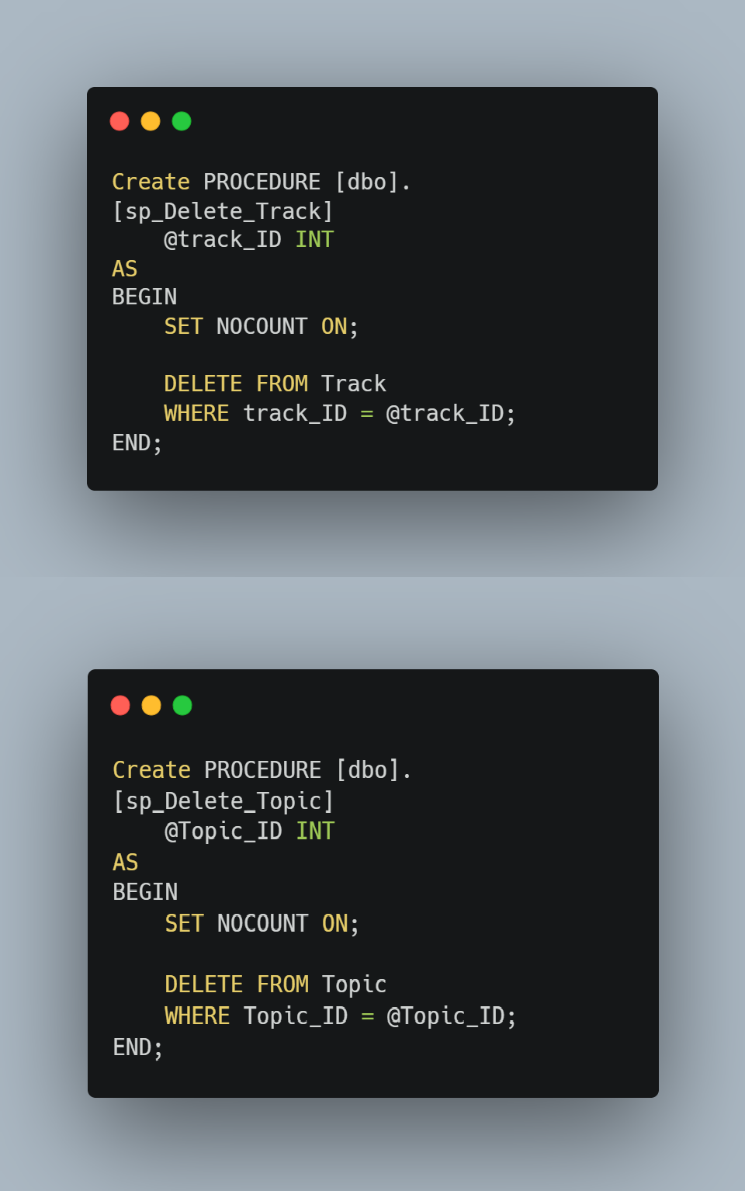

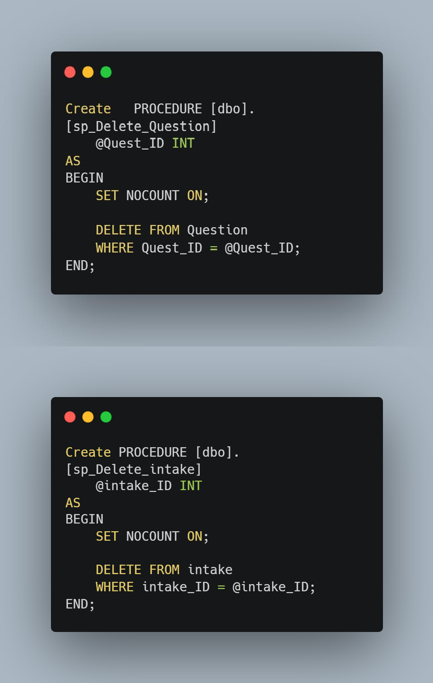

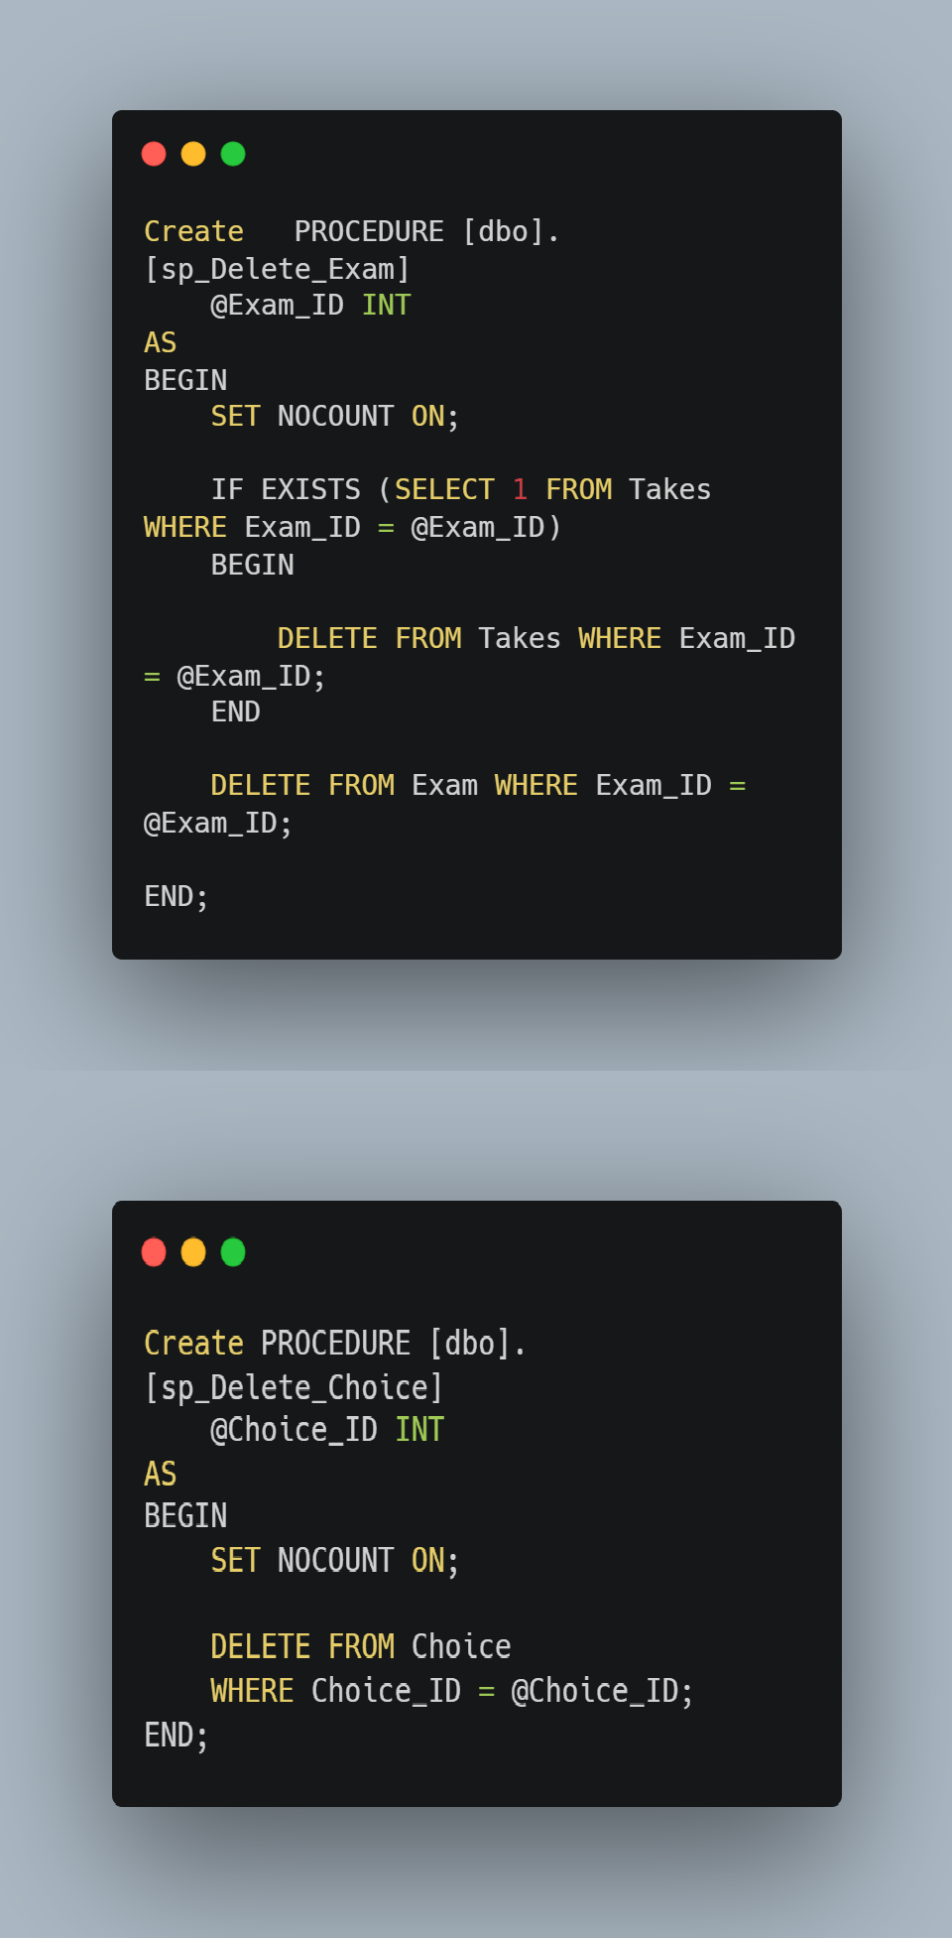

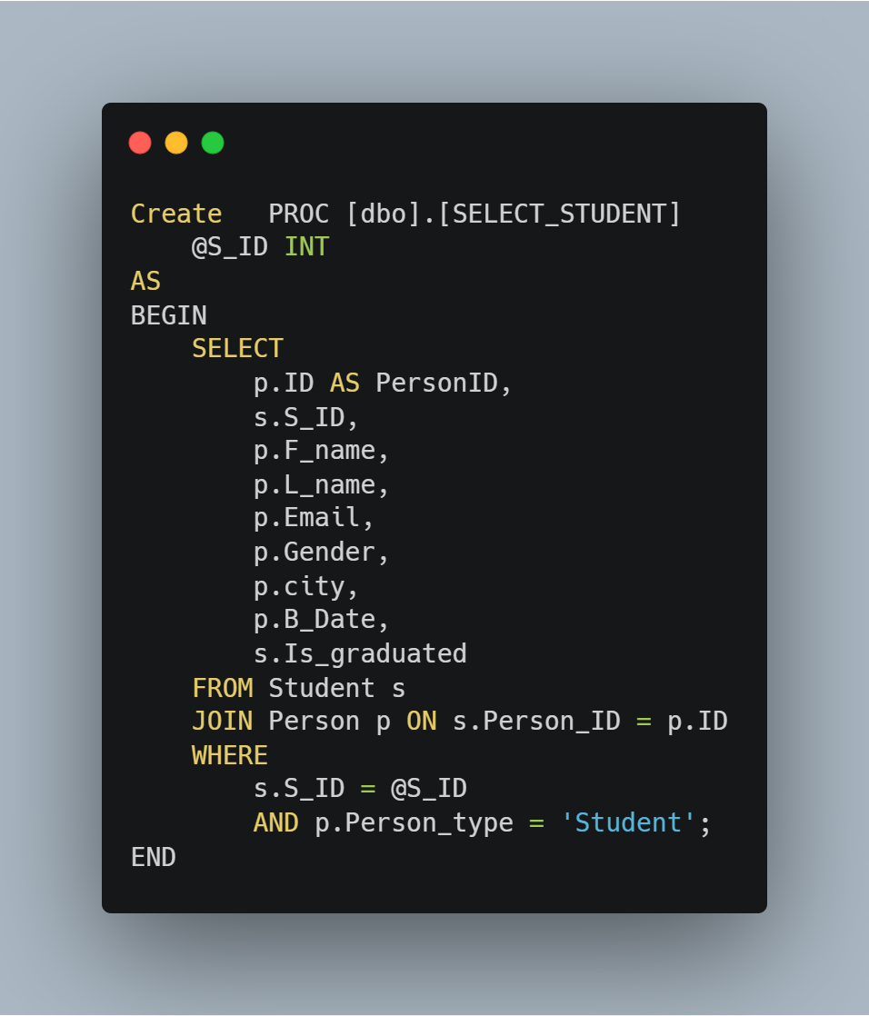

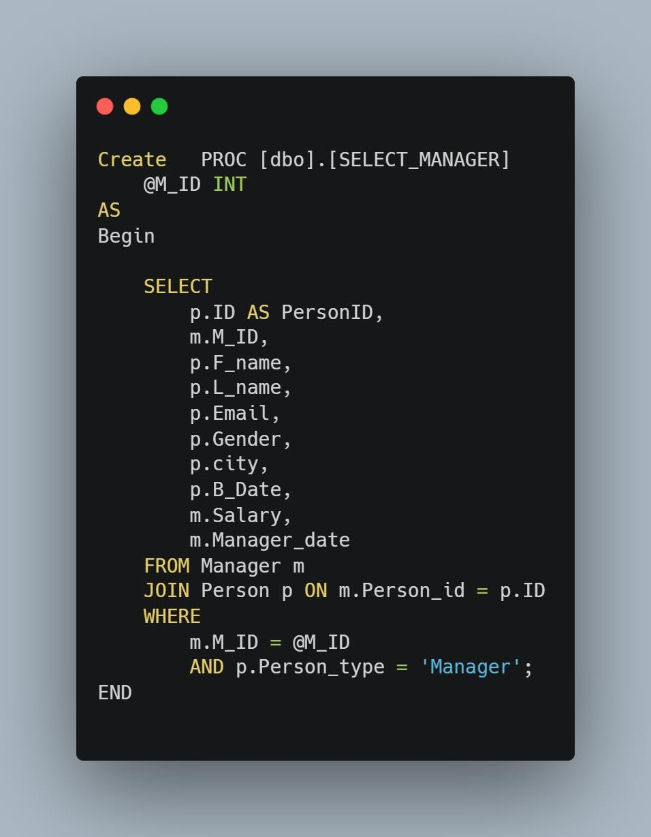

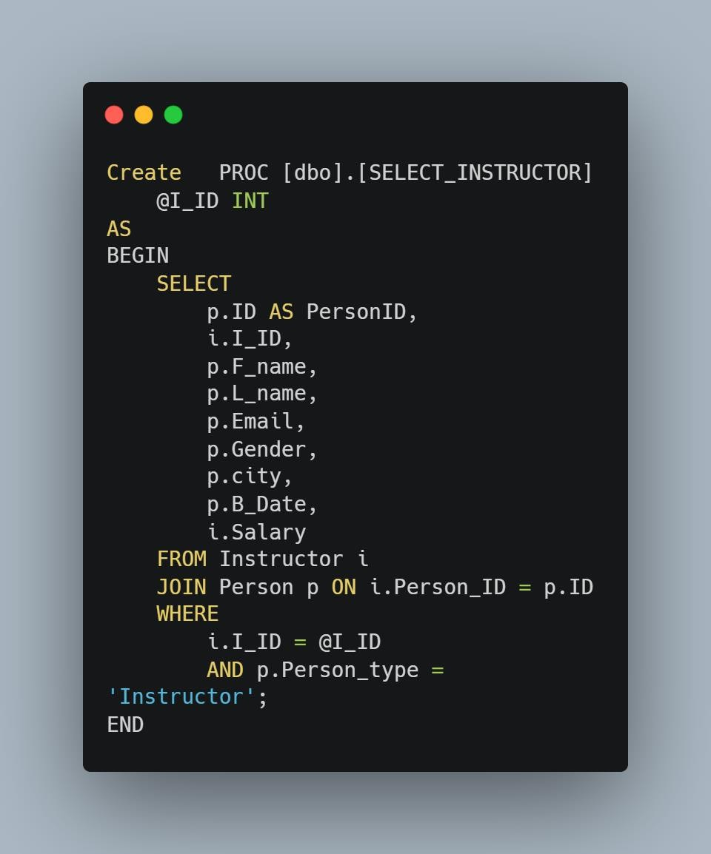

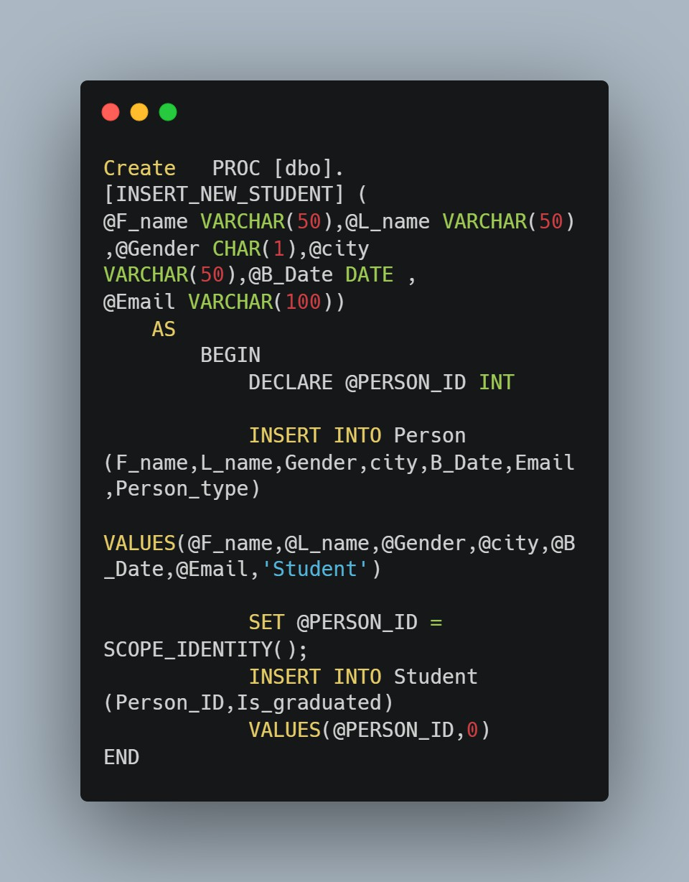

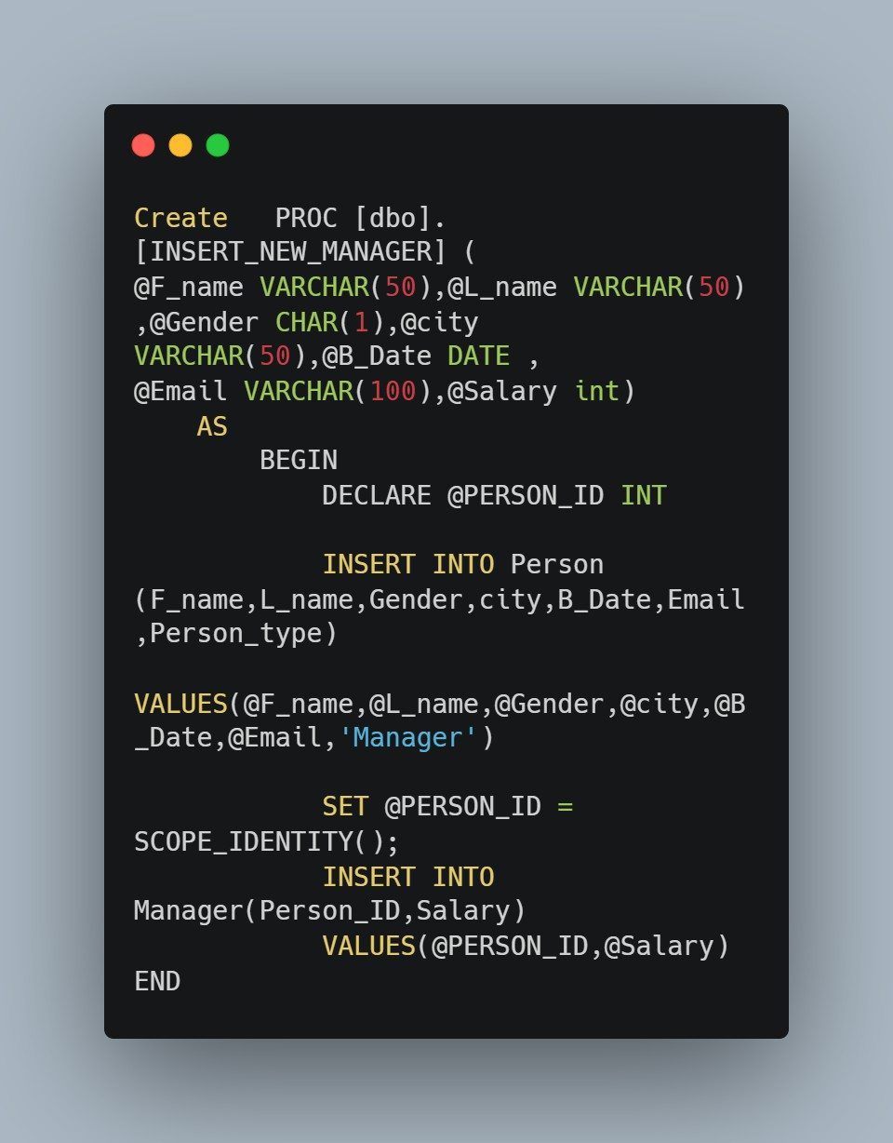

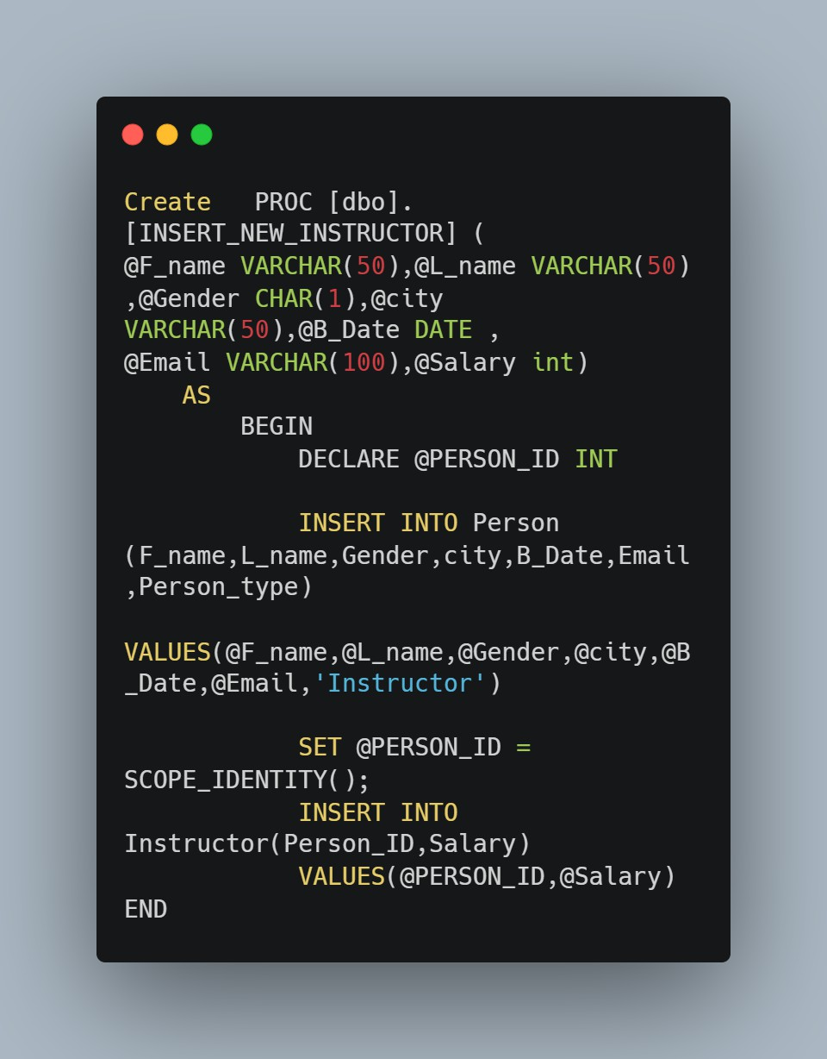

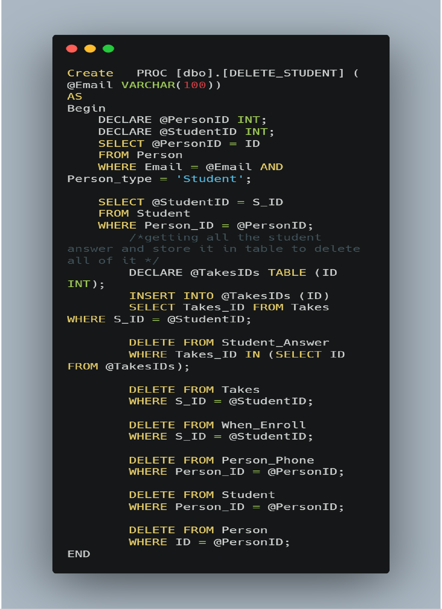

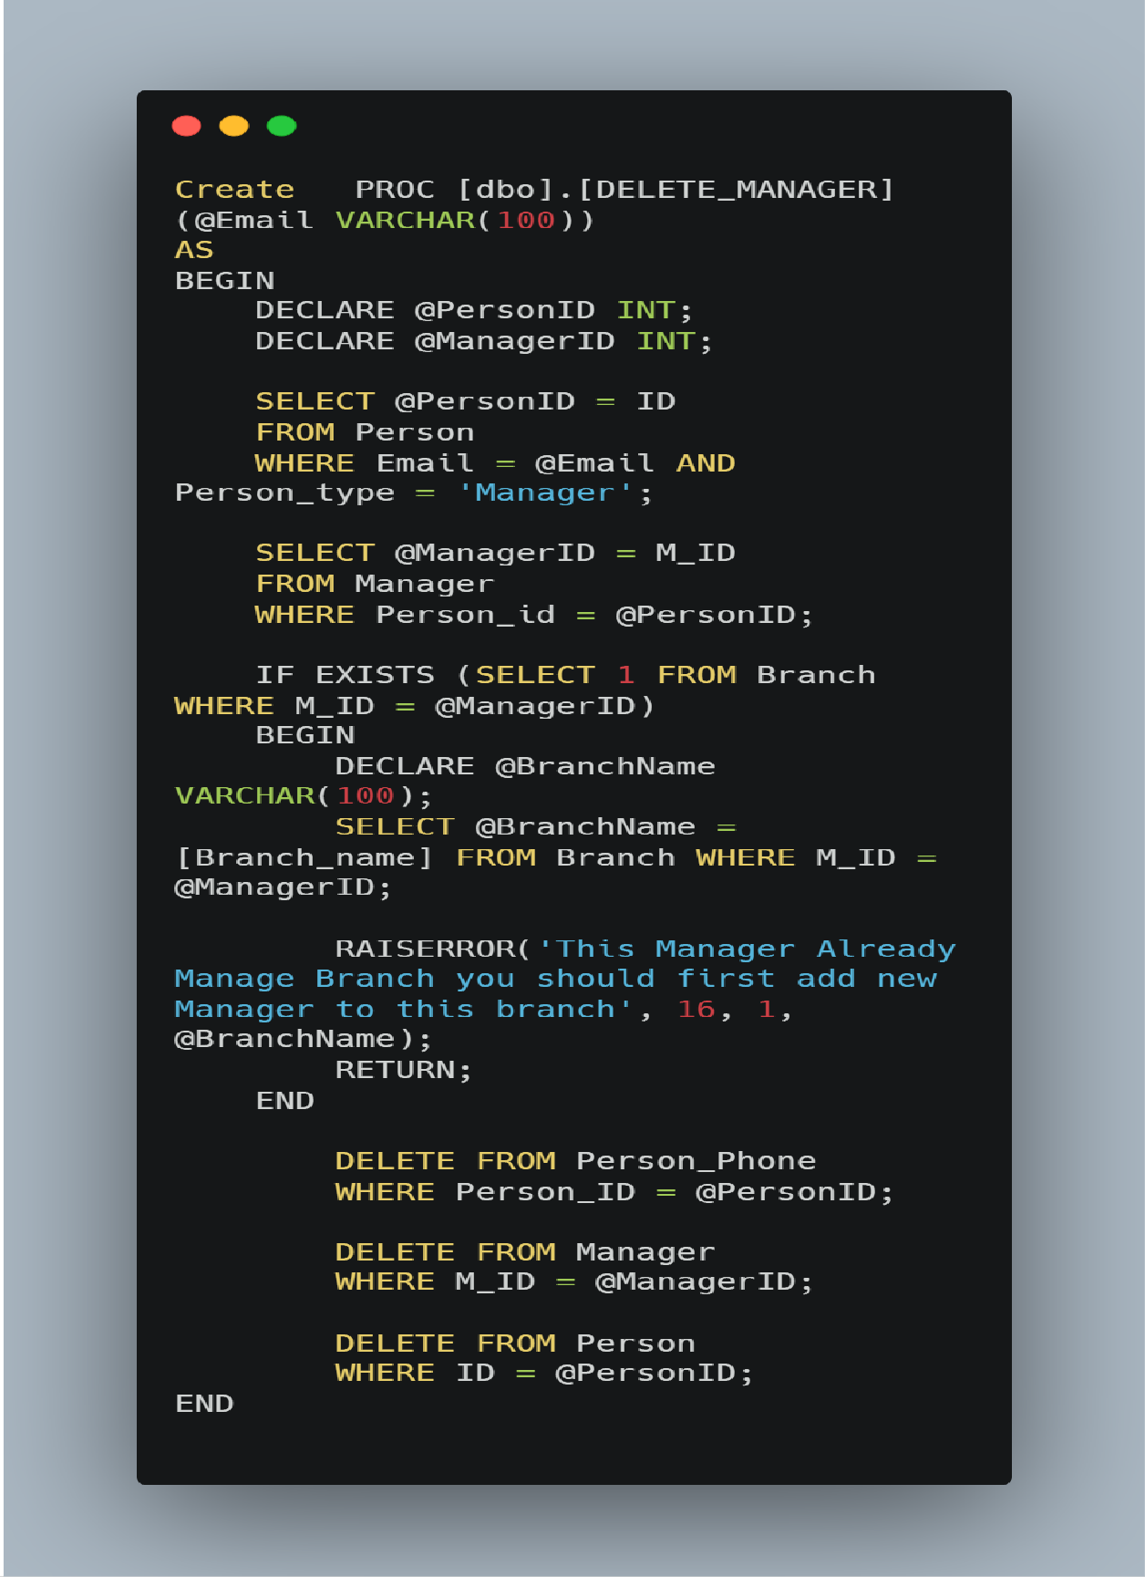

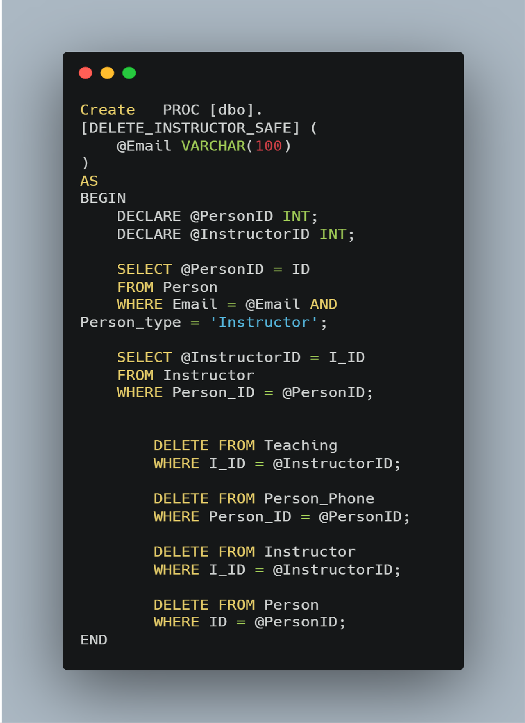

### Fulfill the eight specific reporting requirements for ITI staff.

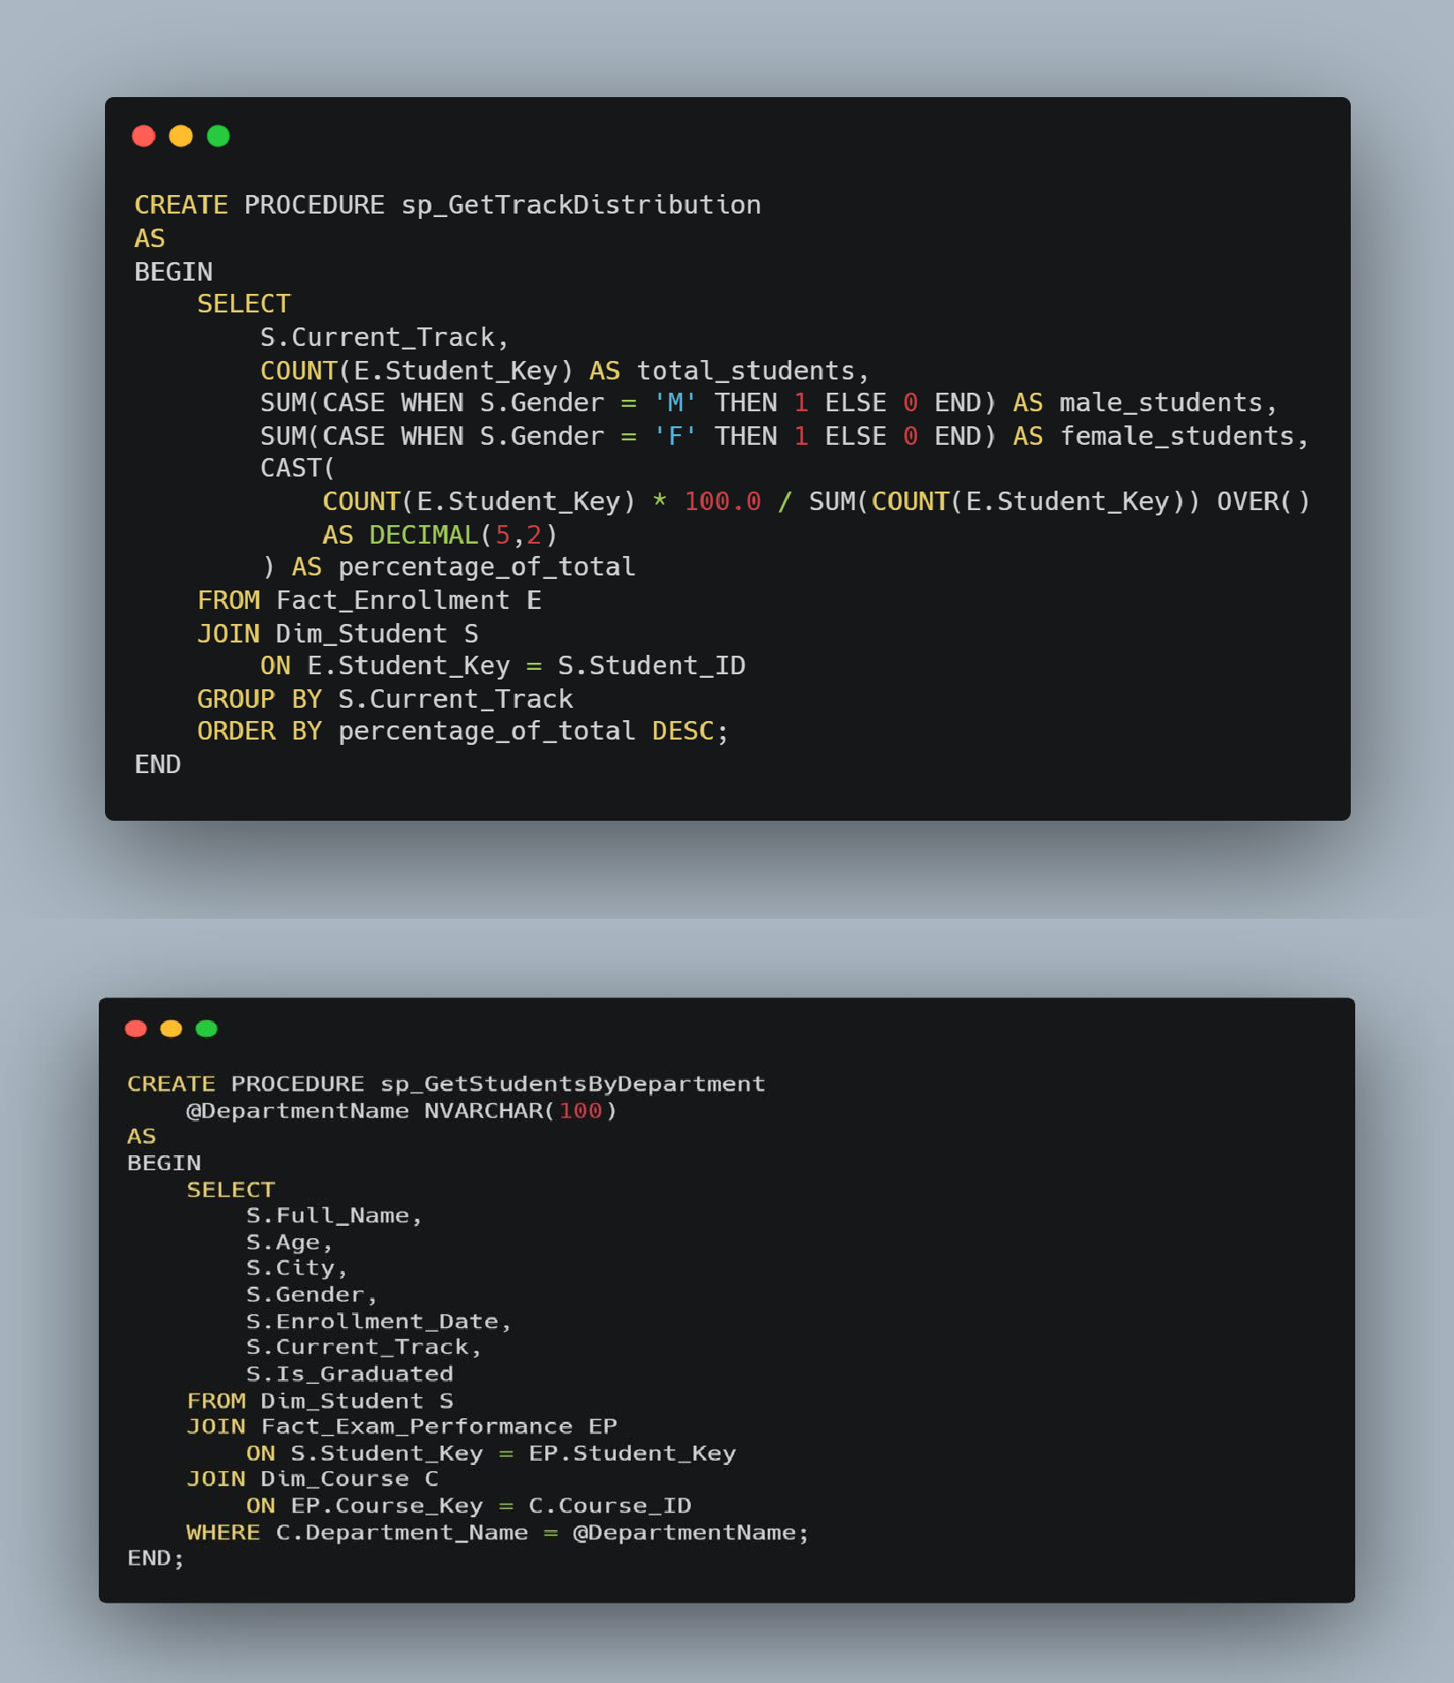

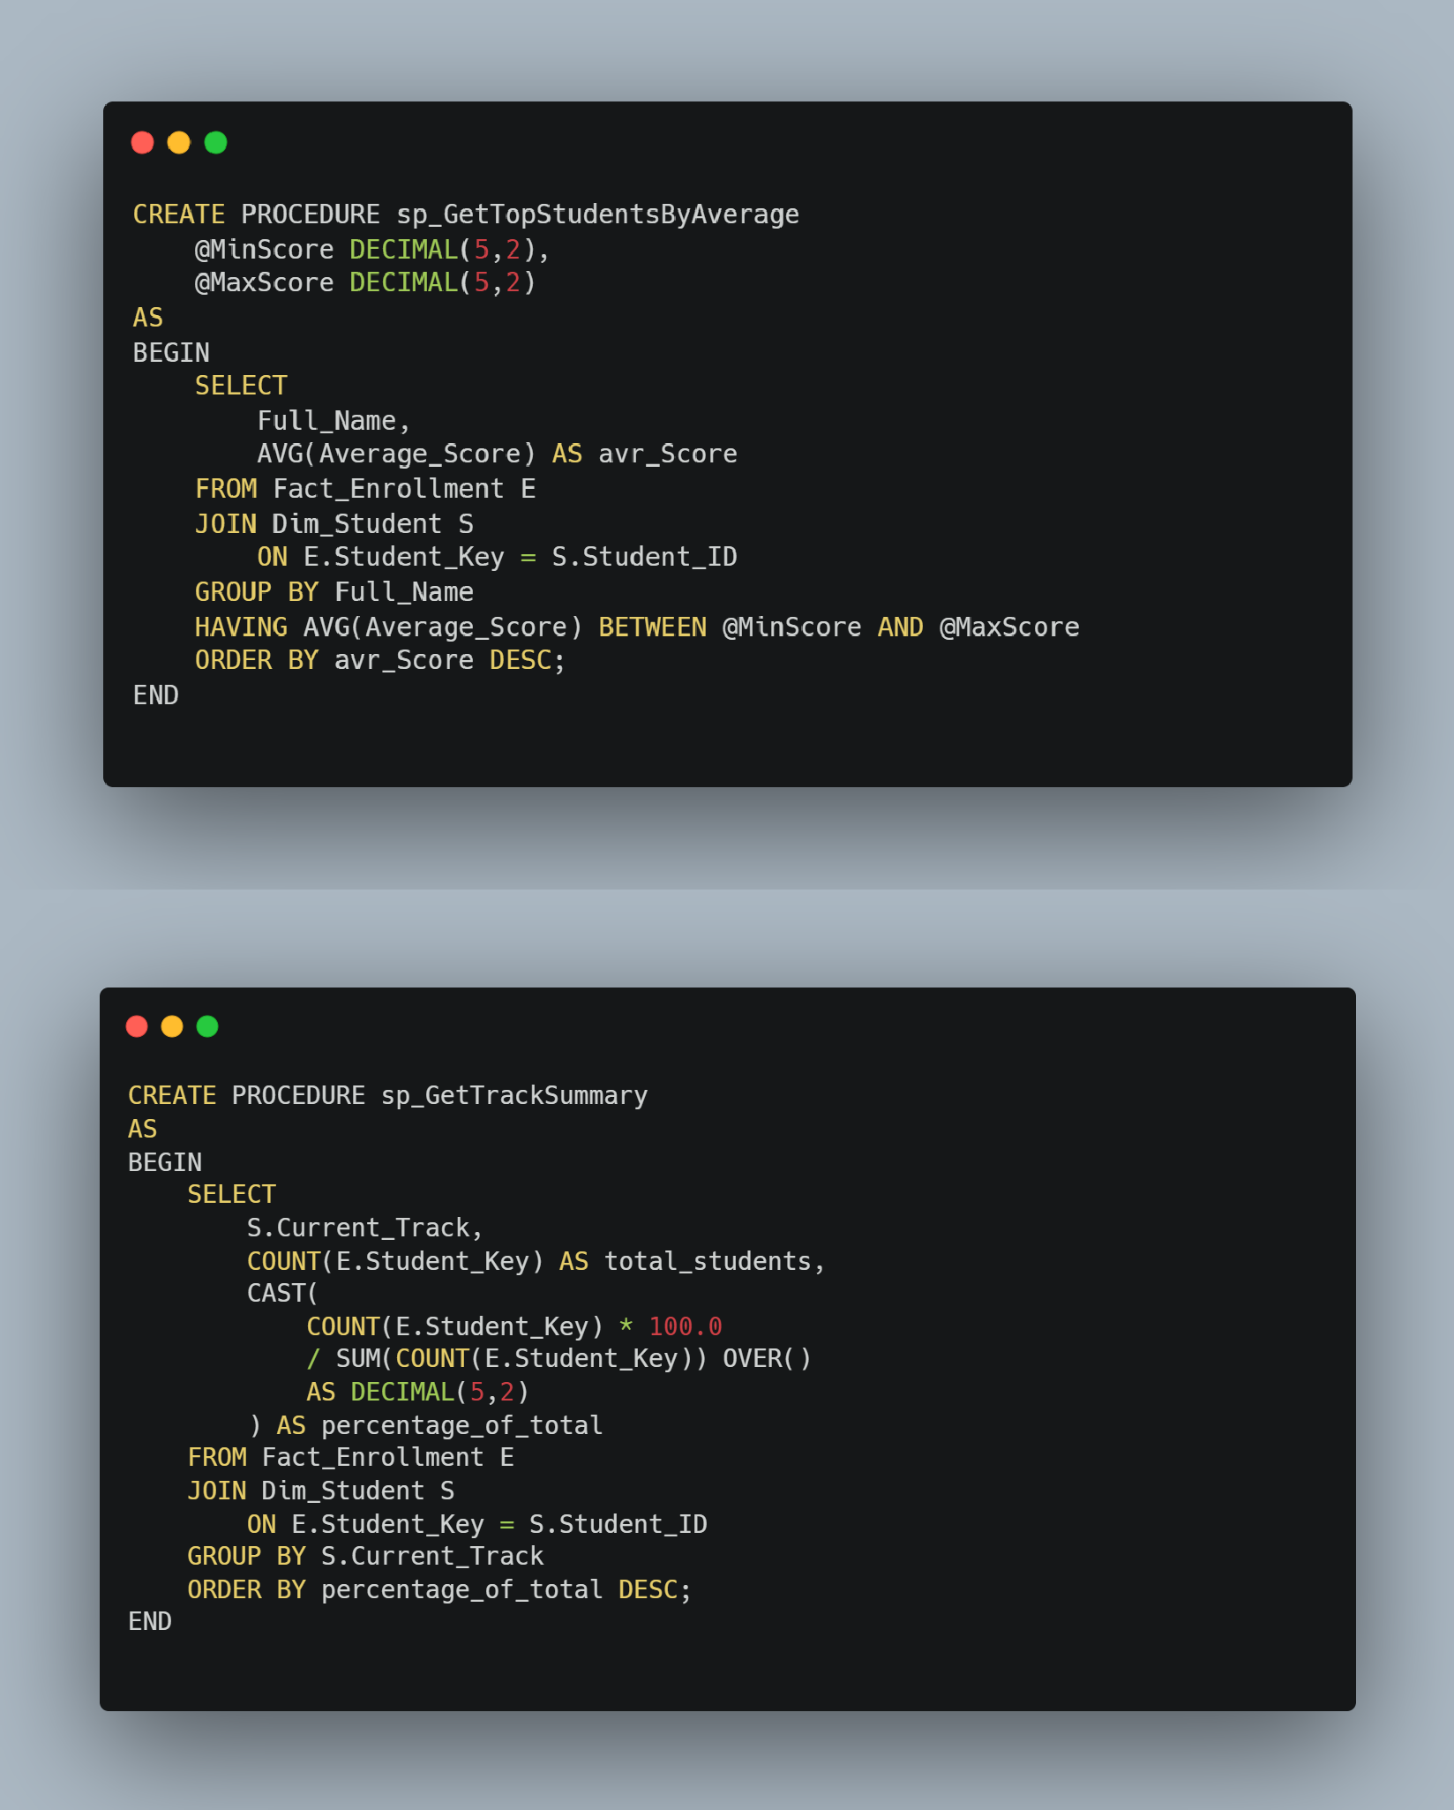

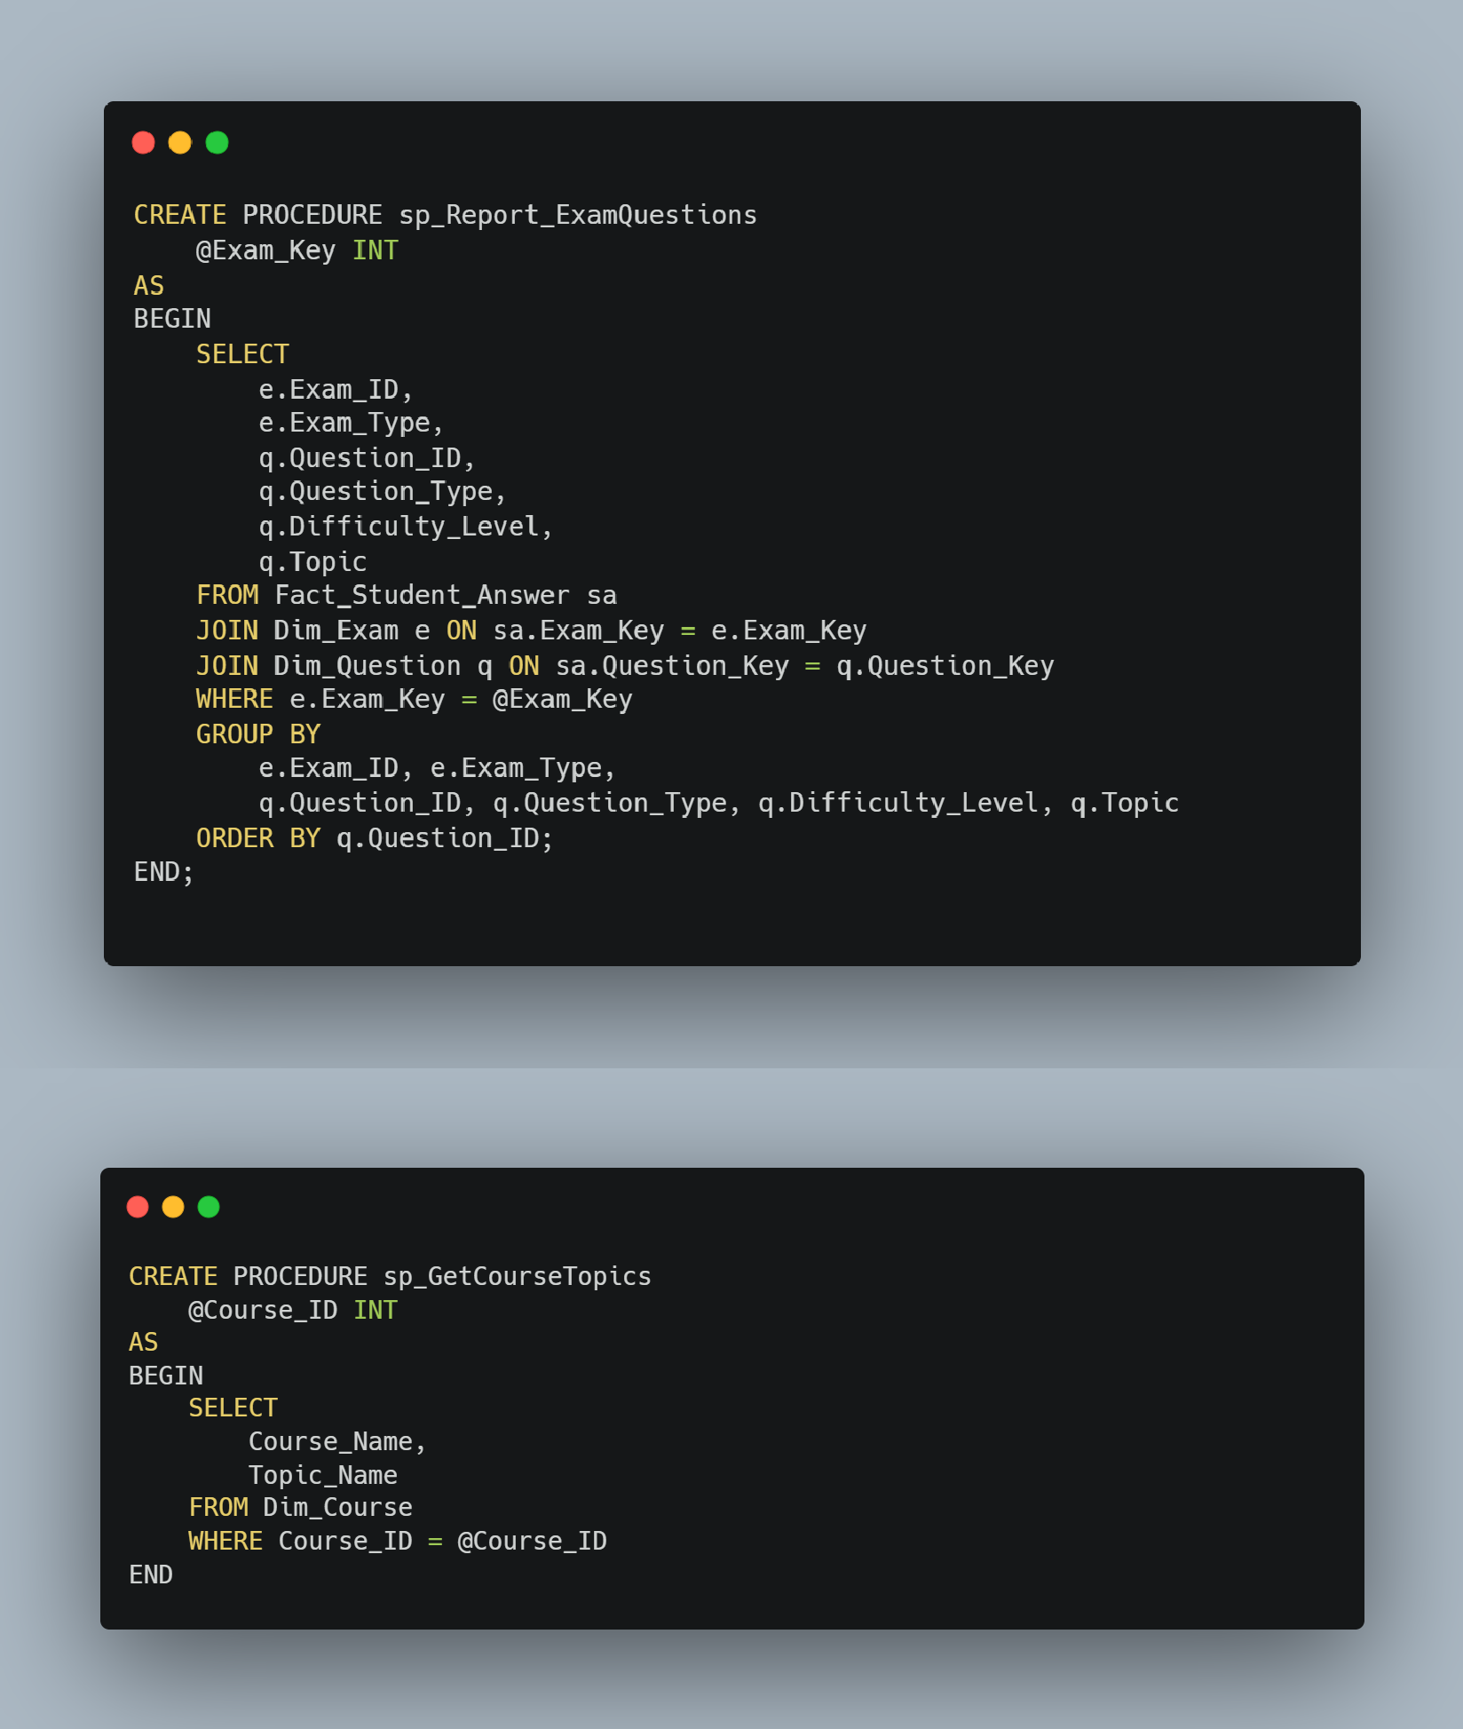

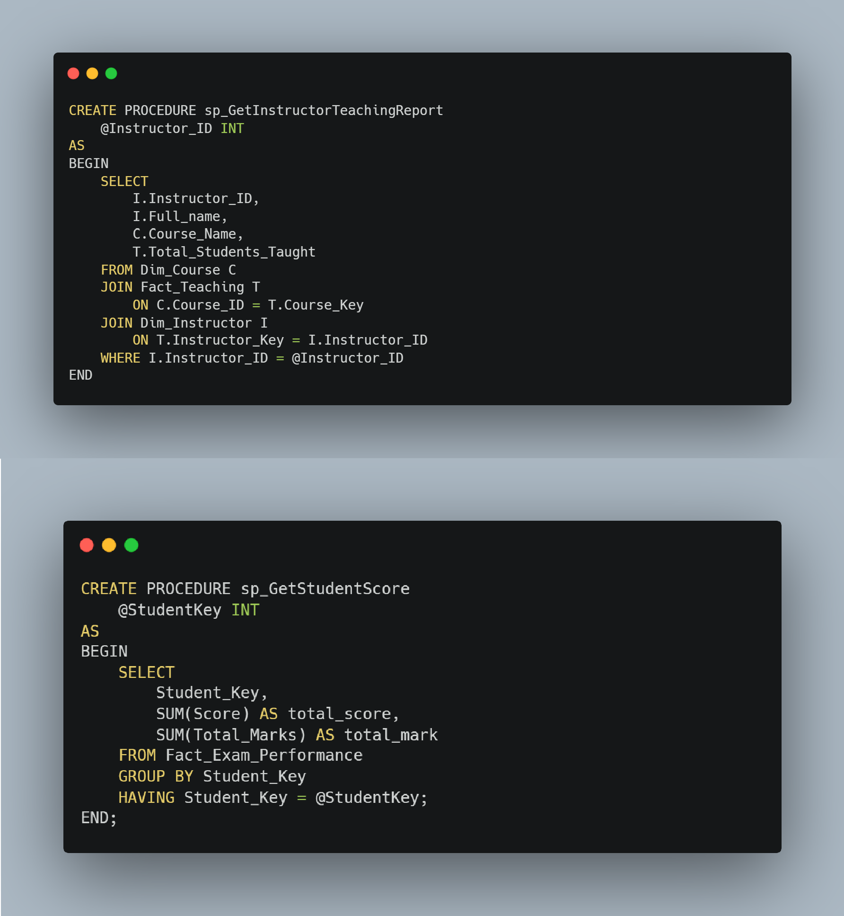

* **System Logic:** Core functionalities for **Exam generation**, **Exam Answers**, and **Exam Correction** were implemented.

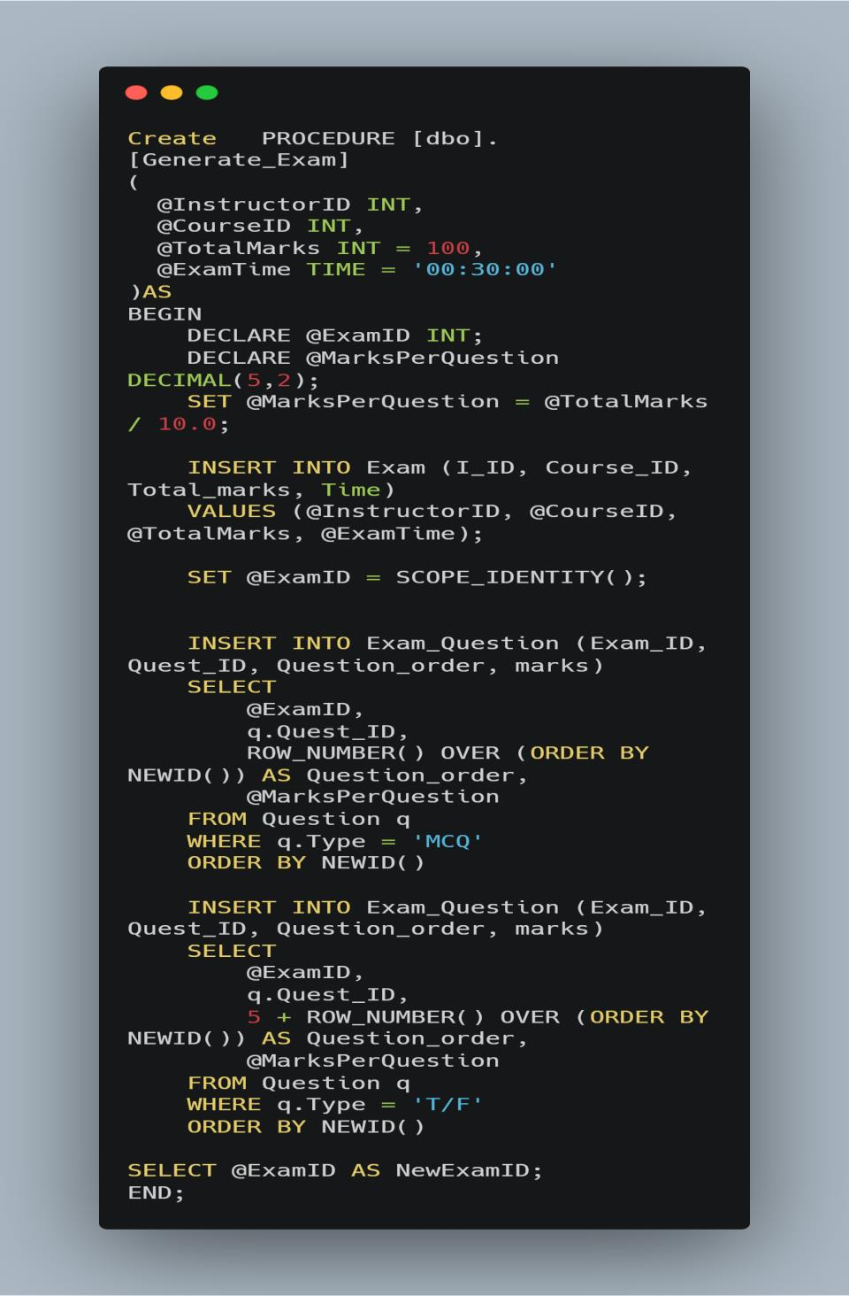

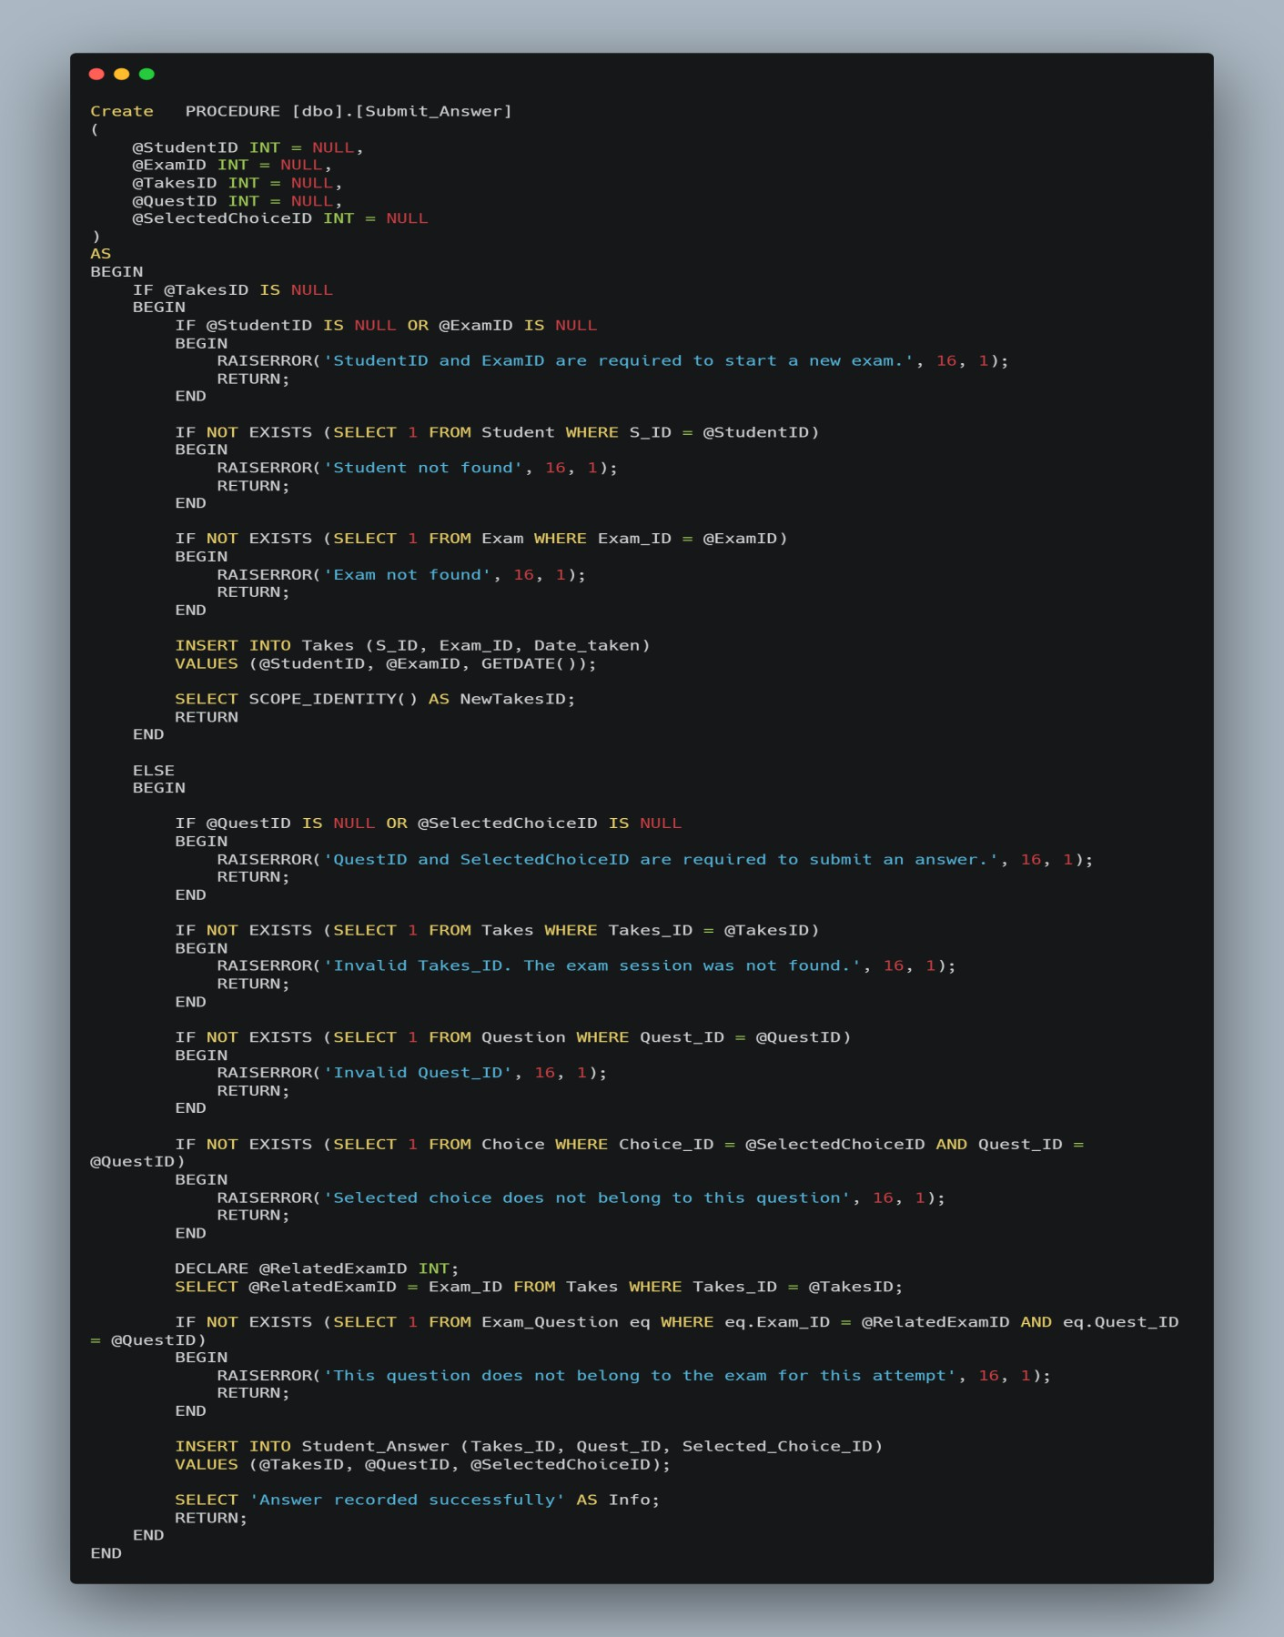

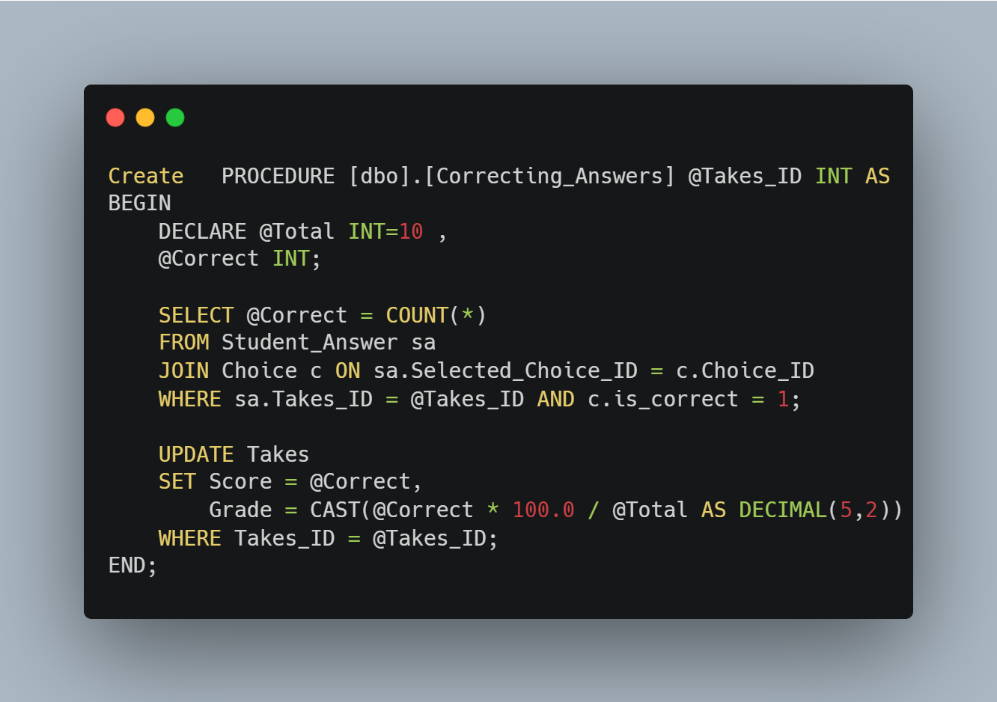

* **ETL (SSIS) Process:** An **SSIS package** was built to perform the ETL process, extracting data from the OLTP source, transforming it, and loading it into the DWH.

### OLTP Database

↓

### [Extract Task]

↓

### [Transform Task]

↓

### [Load to DWH]

↓

### DWH Database

* Dimensions SSIS Data Flow
  1. Student Dim

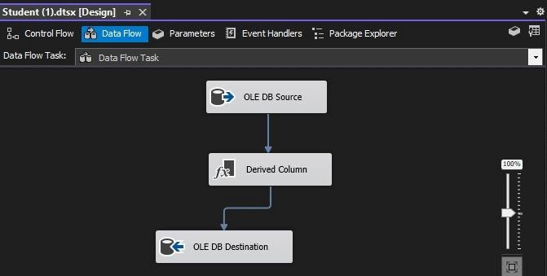

* 1. Instructor Dim

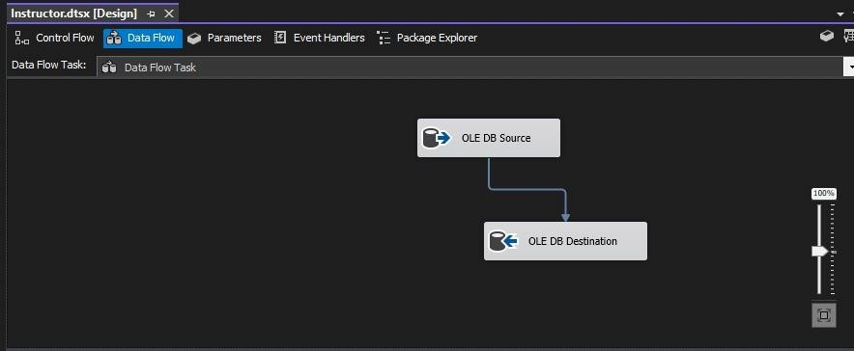

* 1. Course Dim

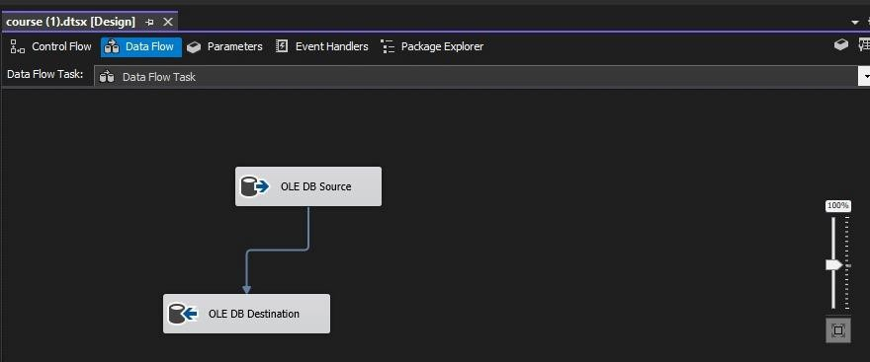

* 1. Intake Dim

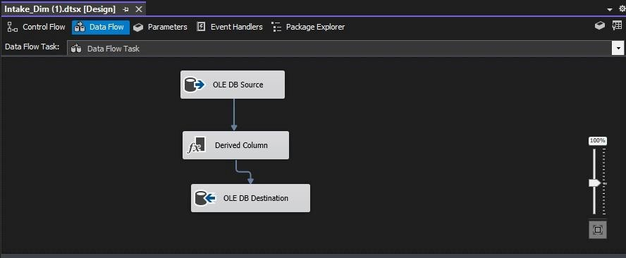

* 1. Question Dim

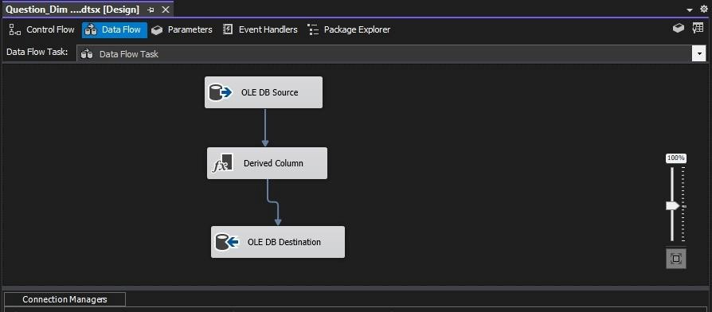

* 1. Track Dim

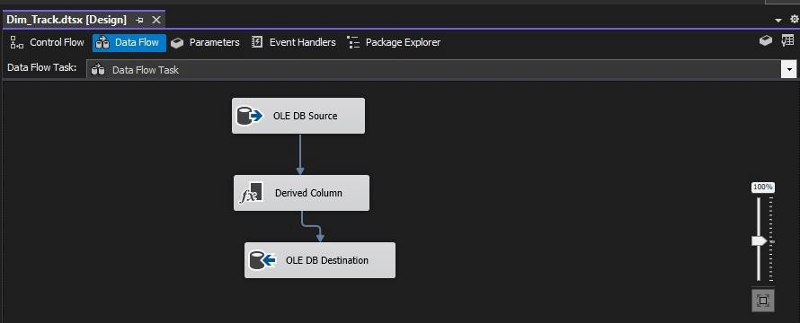

* 1. Classroom Dim

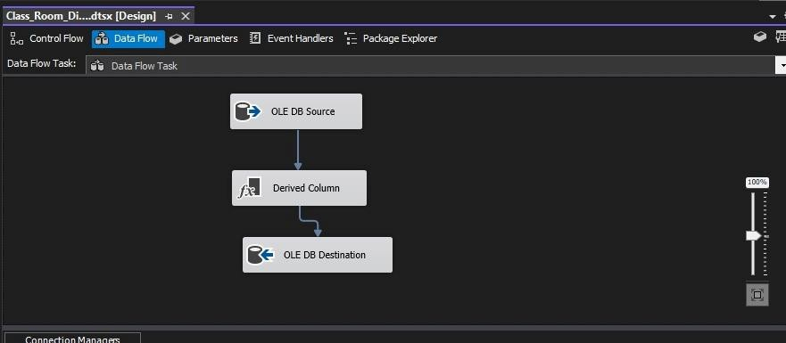

* 1. 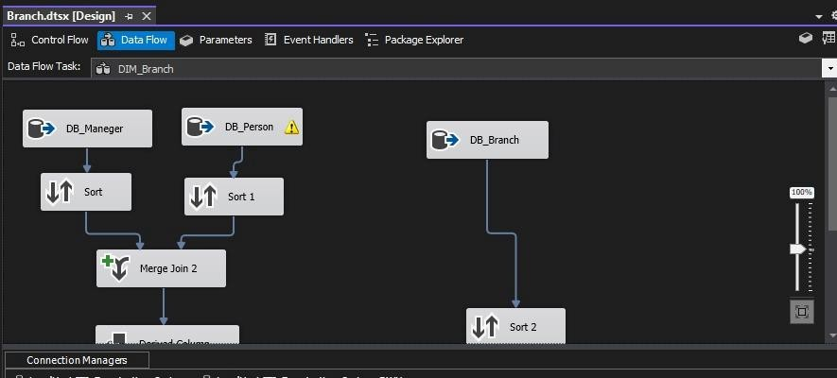Branch Dim
  2. Exam Dim

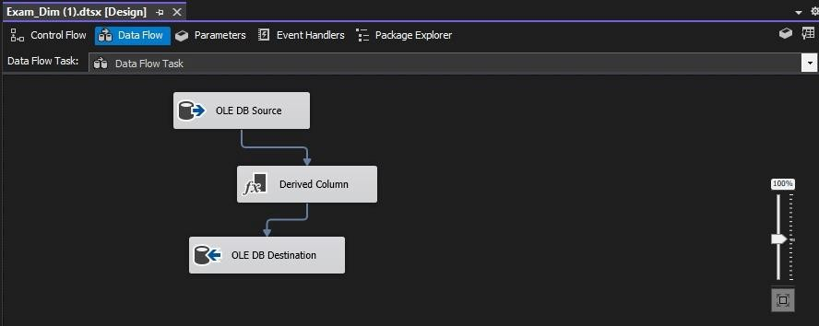

* Facts SSIS Data Flow
  1. Fact Enrollment

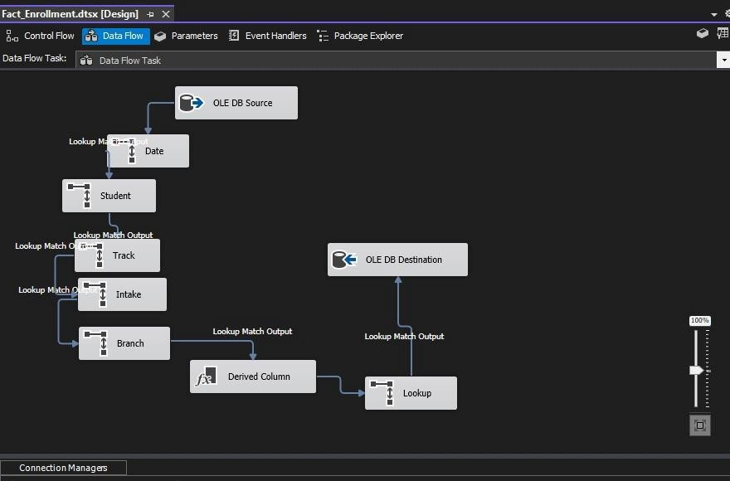

* 1. 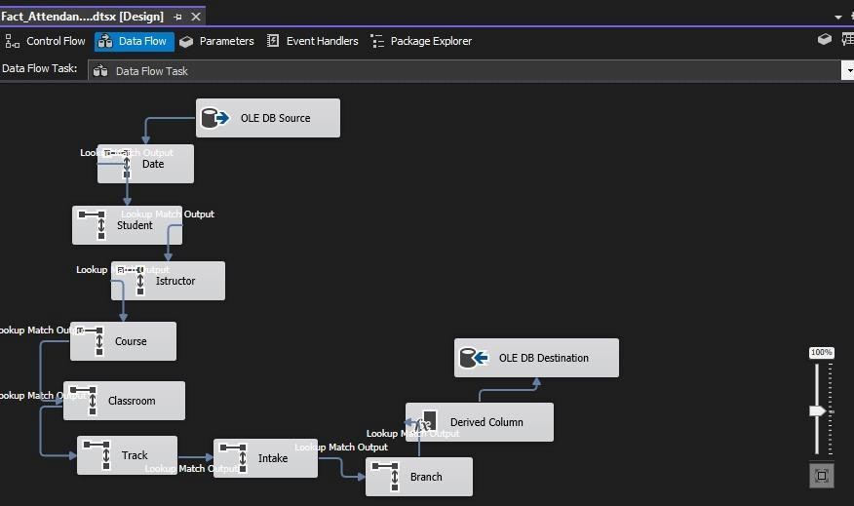Fact Attendence
  2. Fact Exam Performance

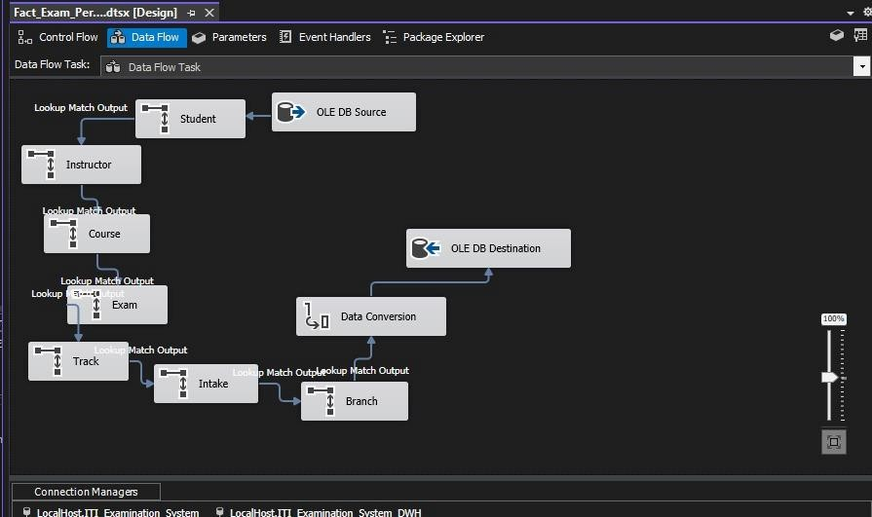

* 1. 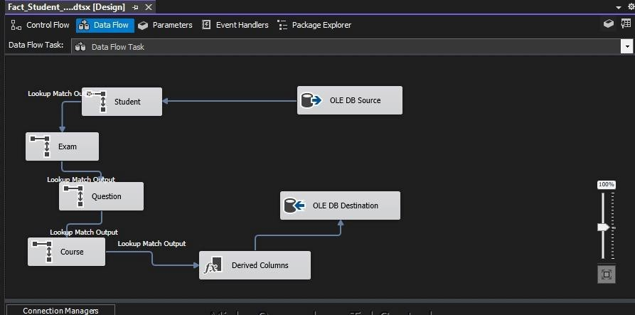Fact Student Answer
  2. Fact Teaching

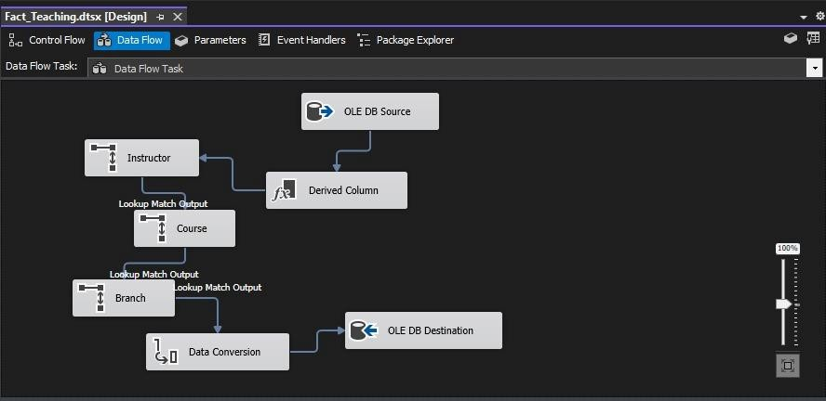

## Reporting & Dashboards:

### **SSRS** was used to build the six required reports, linking them to the stored procedures.

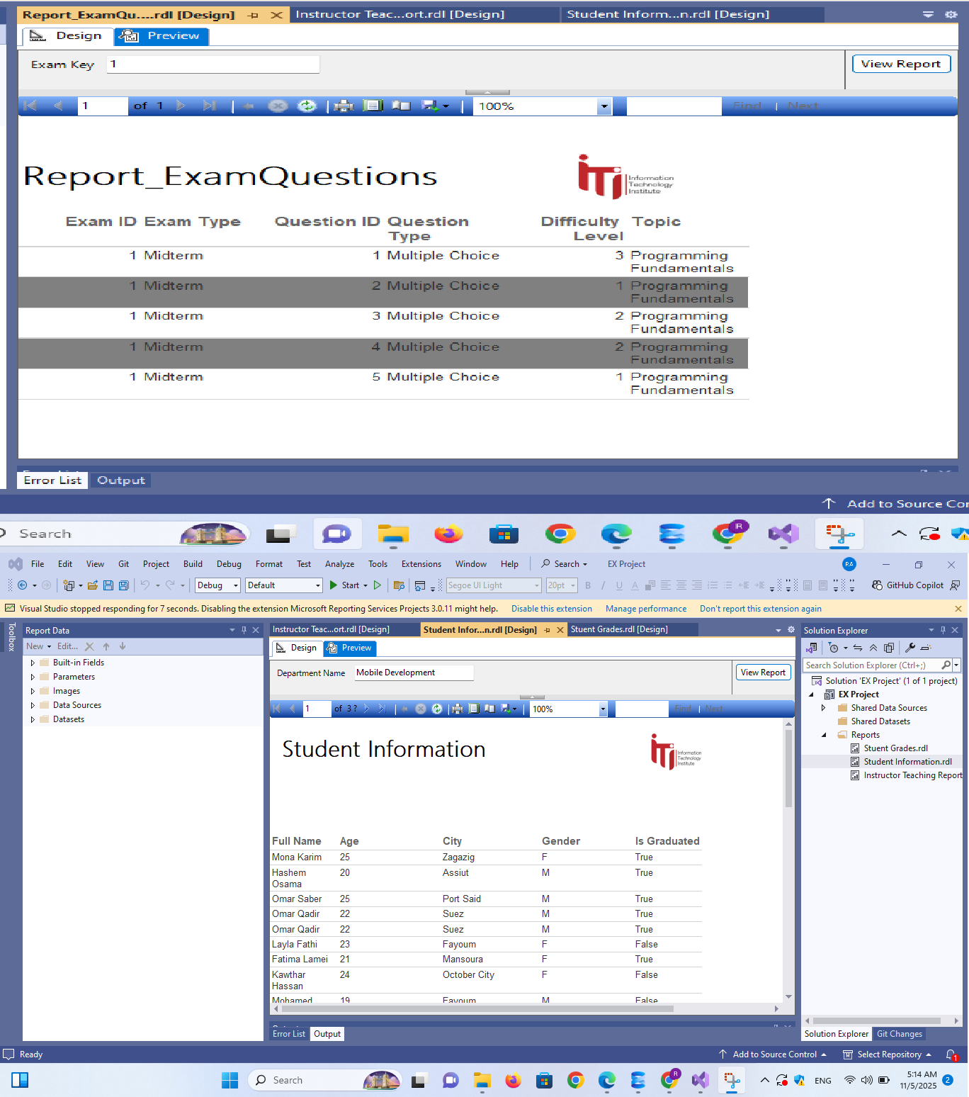

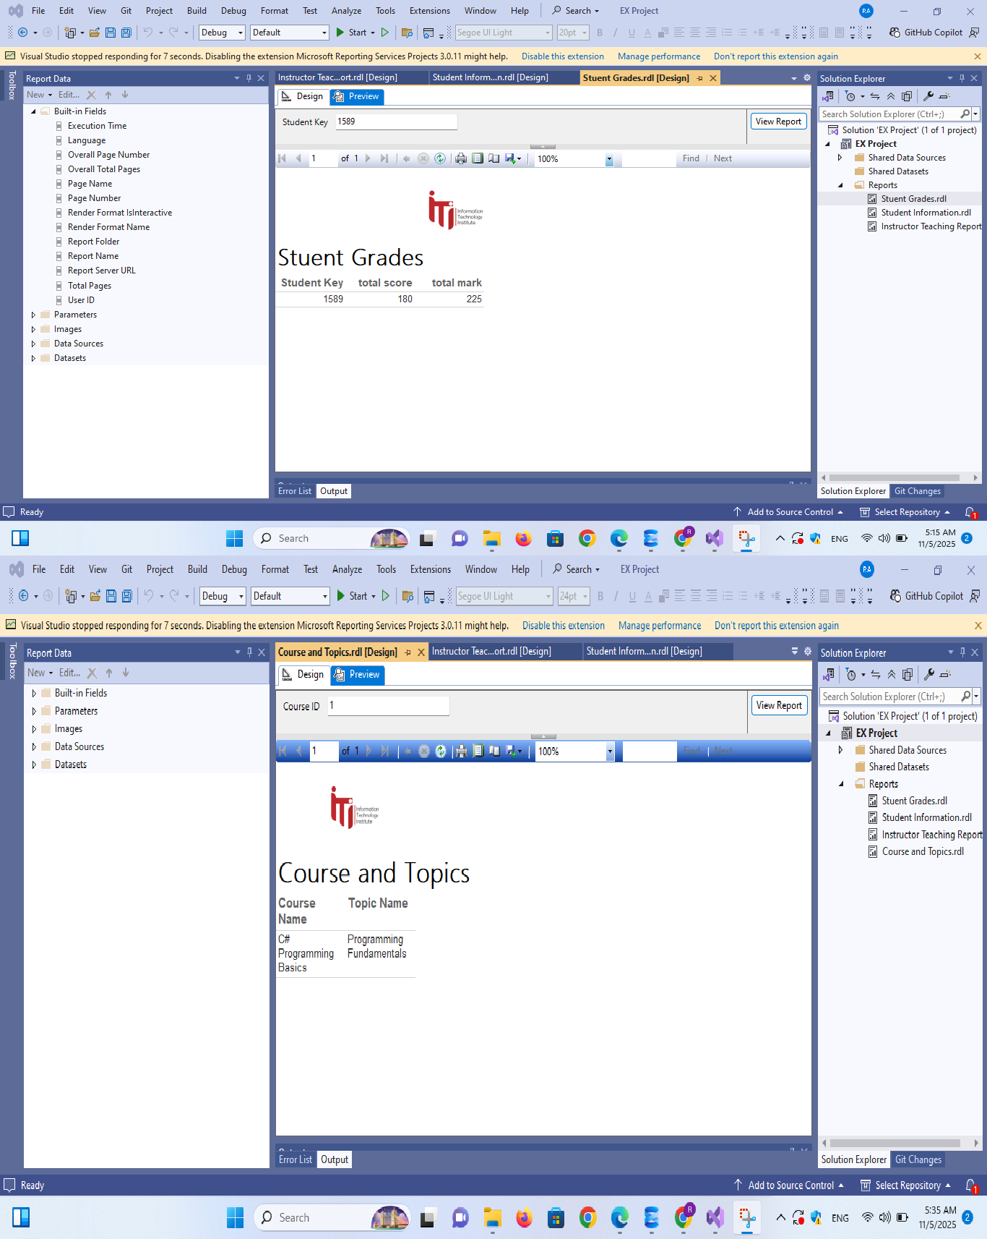

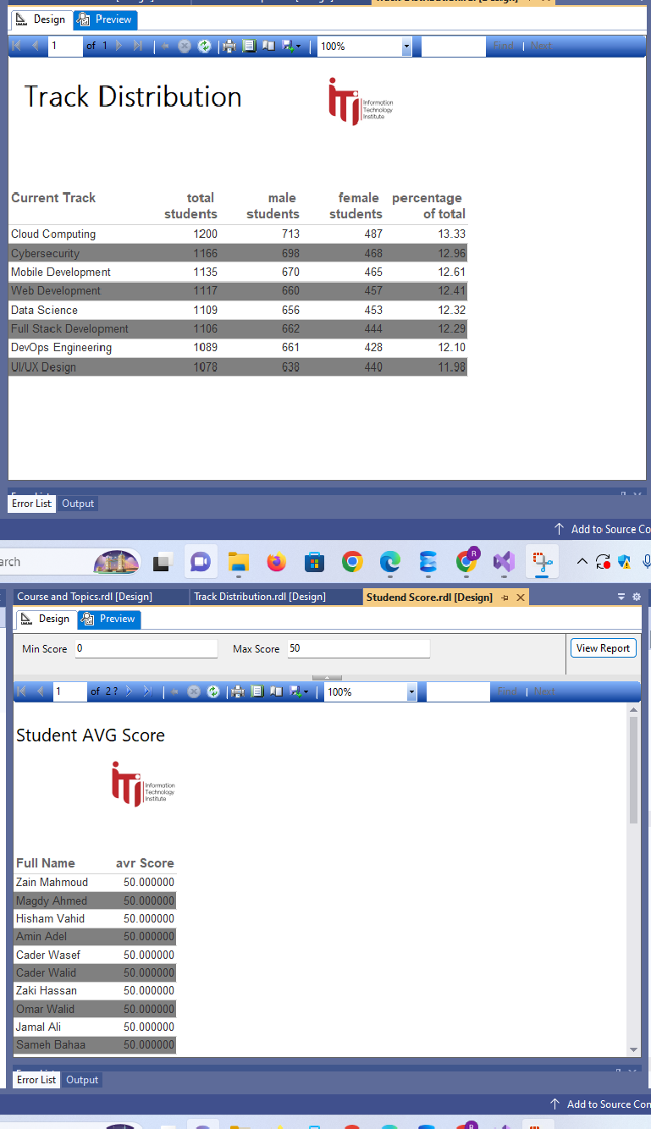

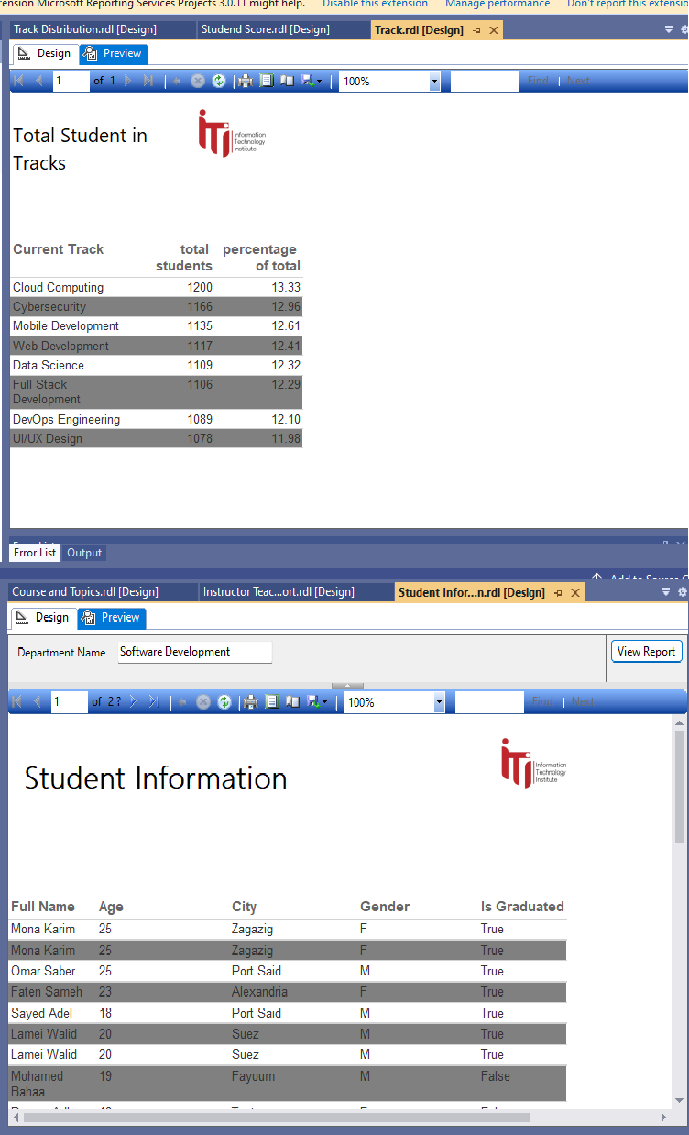

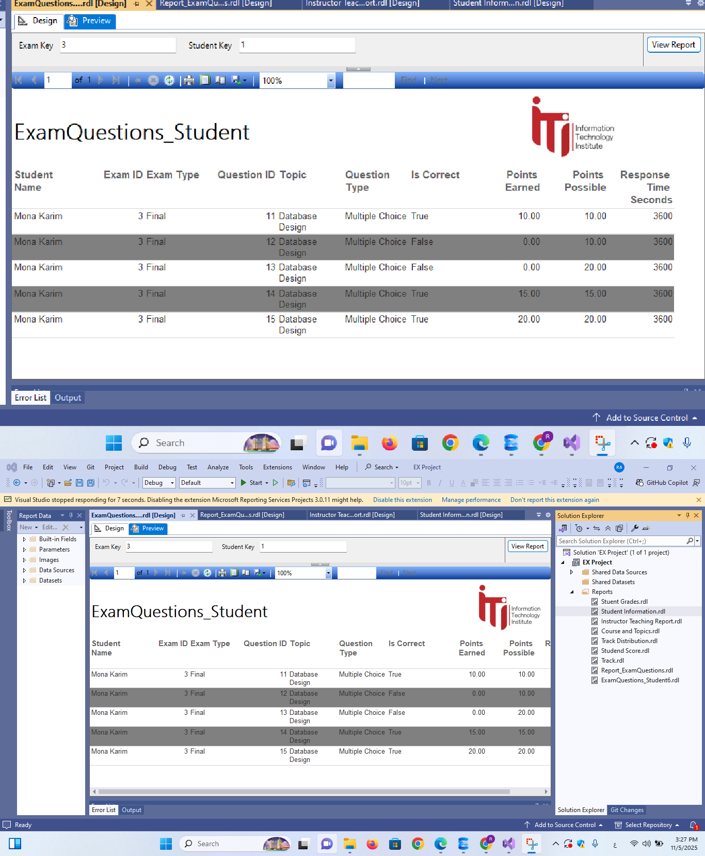

* **Power BI** was used to create interactive analytical dashboards

.

* **Application Development:** A **Web Application** was developed as the primary user interface.

**Authentication System**

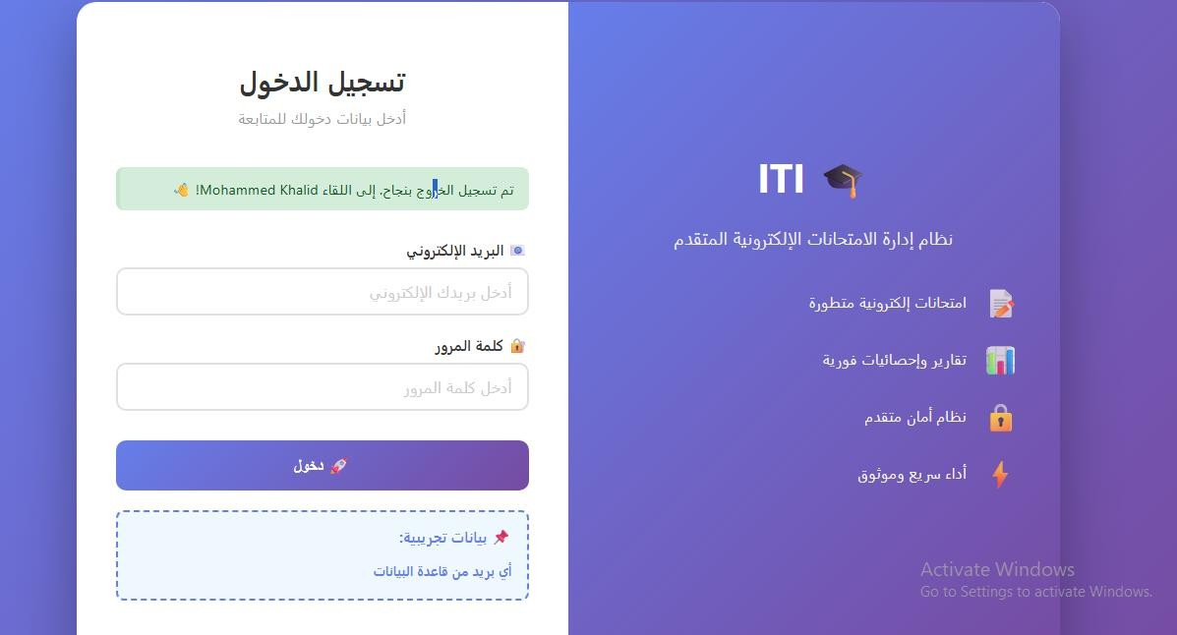

**Features:**

* + **Role-based access control (Student, Instructor, Manager)**
  + **Session management**
  + **Password hashing with bcrypt**
  + **Email-based authentication**

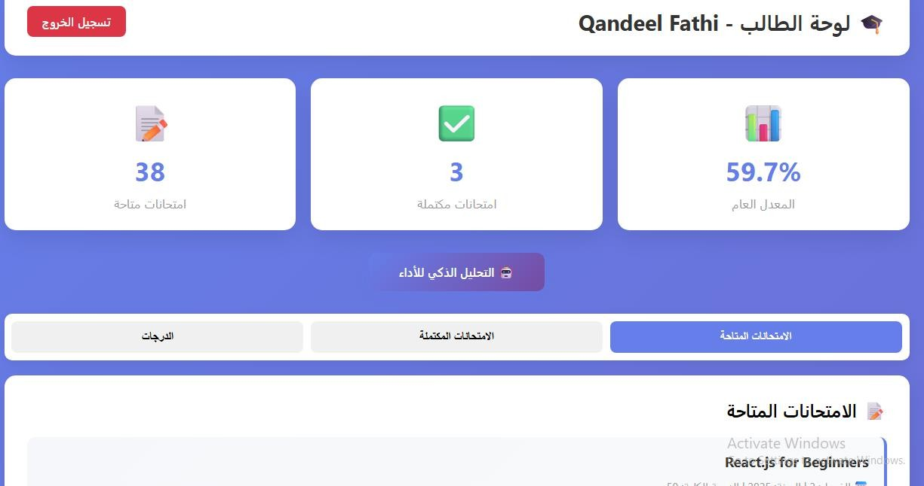**Student Dashboard**

**Features:**

* + **View of the available exams**
  + **Take exams with questions and choices**
  + **Track exam history**
  + **View performance analytics**
  + **Performance prediction (ML)**

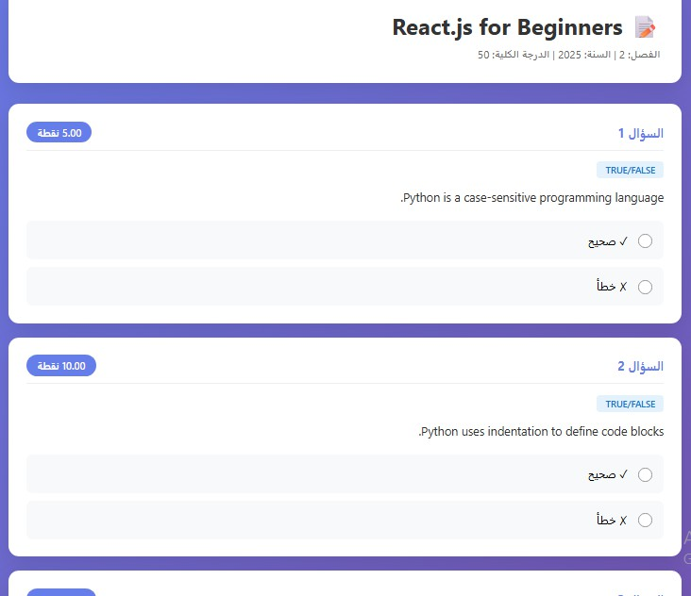**Exam Taking Interface**

**Features:**

* + **Question display with proper formatting**
  + **MCQ with radio buttons**
  + **True/False with clear options**
  + **Short answer and essay support**
  + **Progress tracking**
  + **Auto-save functionality**

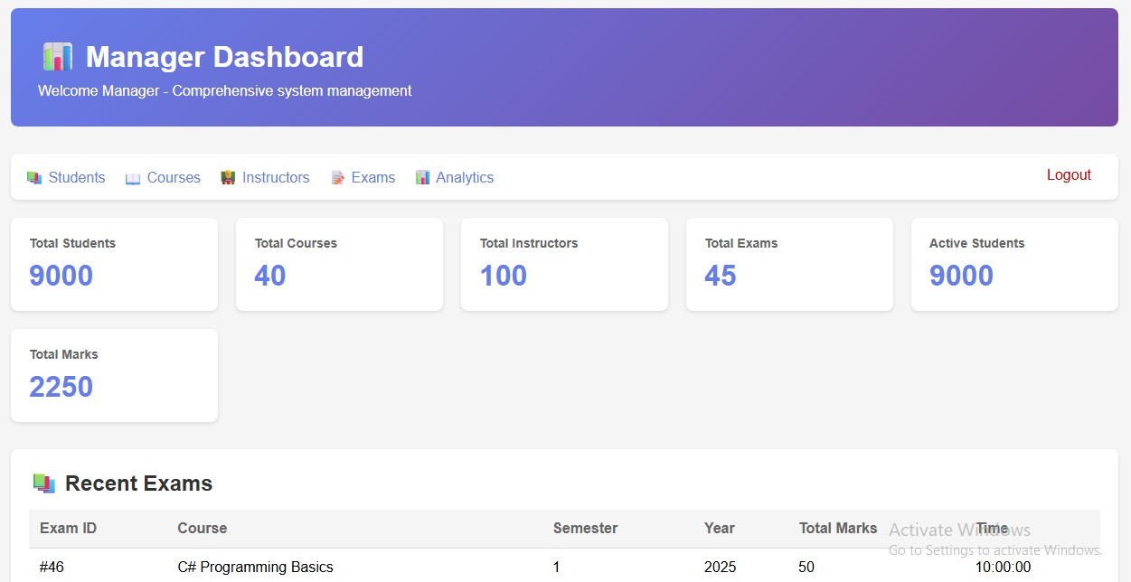**Manager Dashboard**

**Features:**

* + **View all students**
  + **View all courses**
  + **View all exams**
  + **Student performance statistics**
  + **Course analytics**
  + **Trend analysis**

**API Endpoints**

|  |  |  |
| --- | --- | --- |
| **Endpoint** | **Method** | **Purpose** |
| /auth/login | POST | User authentication |
| /auth/logout | GET | User logout |
| /student/dashboard | GET | Student dashboard |
| /student/exam/<id> | GET | Take exam |
| /student/exam/submit | POST | Submit exam |
| /student/ml/analytics | GET | Performance analytics |
| /manager/dashboard | GET | Manager dashboard |
| /manager/ml/dashboard | GET | System analytics |

#### Testing and Verification Phase

Each component was tested to ensure it met the functional requirements.

* + **Stored Procedures:** Tested to ensure they returned the correct data.
  + **SSRS Reports:** Verified to ensure they accepted parameters (like Student ID) and displayed accurate results.
  + **SSIS (ETL) Package:** Tested to validate data integrity after the transfer to the DWH.
  + **Web Application:** The complete user workflow was tested.

#### Deployment and Maintenance Phase

The final solution was deployed for use.

* + **Deployment:** The Web Application, SQL databases, and BI reports were deployed to a production environment.
  + **Maintenance: Database Backup** procedures were established as required , and the **Database Dictionary** was provided as final documentation.

## The Used Tools in the Project (SW and HW)

1. **Hardware**

This project relies on standard client-server architecture and does not require specialized hardware.

* + **Client Machines:** Personal Computers used by developers, ITI staff, and students to access the system.
  + **Database Server:** A server to host the Microsoft SQL Server databases (both OLTP and DWH).
  + **Application Server:** A server to host the deployed Web Application and the SSRS/Power BI services.

1. **Software**
2. **Database & BI Platforms**

|  |  |
| --- | --- |
| **Tool** | **Description** |
| **Microsoft SQL Server** | The core Relational Database Management System (RDBMS) used to design, build, and host both the ITI_Examination_System (OLTP) and ITI_Examination_System_DWH (DWH) databases. |
| **SQL Server Integration Services (SSIS)** | The platform used to perform the **ETL (Extract, Transform, Load)** process. It was used to build the package that moves and transforms data from the operational OLTP database to the analytical DWH. |
| **SQL Server Reporting Services (SSRS)** | Used to create, deploy, and manage the **paginated reports** required by ITI staff (e.g., student grades, instructor course loads). The reports were connected to stored procedures in the OLTP database. |
| **Microsoft Power BI** | The Business Intelligence service used for data visualization. It was connected to the DWH to create **interactive dashboards and analytical reports** for high-level decision-making. |

1. **Development Languages & Frameworks**

|  |  |
| --- | --- |
| **Language / Framework** | **Description** |
| **T-SQL**  **(Transact- SQL)** | The primary language used for all database-level logic. This includes creating the database schemas, all tables, and the **stored procedures** used for CRUD operations and generating the SSRS reports. |

|  |  |
| --- | --- |
| **Language / Framework** | **Description** |
| **ASP.NET (C#)** | The server-side web framework used to build the **Web Application**. It handles the backend logic, user authentication, and communication between the user interface and the SQL Server database. |
| **HTML / CSS /**  **JavaScript** | The standard client-side technologies used to build the user interface (UI) of the **Web Application**. HTML structures the pages, CSS styles them, and JavaScript adds interactivity. |

1. **IDEs & Development Tools**

|  |  |
| --- | --- |
| **Tool** | **Description** |
| **SQL Server Management Studio (SSMS)** | The primary IDE for all database administration and development. It was used to write and execute the DWH.sql and OLTP.sql scripts, manage tables, and develop/test the stored procedures. |
| **Microsoft Visual Studio** | The main Integrated Development Environment (IDE) used to develop the three core components of the project: the **SSIS (ETL) packages**, the **SSRS reports**, and the **ASP.NET Web Application**. |
| **Power BI Desktop** | The desktop application used to design, author, and test the Power BI dashboards and reports before publishing them to the Power BI service for ITI staff to access. |

1. **AI Development Assistants**

|  |  |
| --- | --- |
| **Tool** | **Description** |
| **ChatGPT** | A large language model used for generating code snippets, debugging, and explaining complex programming concepts. |
| **Gemini** | Used for brainstorming logic solutions, assisting with SQL query optimization, and drafting documentation. |
| **Perplexity AI** | An AI-powered search tool used to quickly find precise technical answers and access official documentation for the project's tools and libraries. |

# Project Specification

#### Functional Requirements

* + - Build an **automated system** to perform **online exams**.
    - Automate core functions: **Exam generation**, **Exam Answers**, and **Exam Correction**.
    - Build an SQL database and use **Stored Procedures** for all (Select, Insert, Update, Delete) operations.
    - Provide **6 specific reports** for ITI staff via stored procedures, including:
      * Student information by Department.
      * A student's grades by Student ID.
      * An instructor's courses and student count by Instructor ID.
      * Course topics by Course ID.
      * Exam questions and choices by Exam number.
      * Exam questions and a specific student's answers.
    - Develop **Power BI Dashboards** for visualization.
    - Provide a user interface (Desktop Application or Web Application).

#### Non-Functional Requirements

* + - **Reliability:** The system must include a **Database Backup** mechanism.

#### Maintainability:

* + - * A **Database Dictionary** must be provided as documentation.
      * Use of Stored Procedures centralizes business logic.
    - **Data Integrity:** Enforce strict data rules using database constraints (like

CHECK and FOREIGN KEY constraints visible in OLTP.sql).

* + - **Scalability:** A separate Data Warehouse (DWH) (ITI_Examination_System_DWH) is designed to handle complex analytical queries without impacting the operational system.

# Problems Encountered and Solutions

During development, we faced several challenges related to data integrity, performance, and maintainability. Here is how we solved them.

#### Problem: Data Integrity on Deletion

* + **Issue:** A significant challenge was ensuring that deleting a primary record (like a Student or Instructor) would not corrupt the database. A simple DELETE command would fail or leave "orphan" records if that entity was referenced by foreign keys in other tables (e.g., a student's exam answers or a manager's branch).
  + **Solution:** We implemented **"safe delete" stored procedures** that manage the entire deletion workflow in the correct order.
    - **Example (Exam):** The sp_Delete_Exam procedure first checks for and deletes all associated student attempts from the Takes table *before* deleting the exam itself.

#### Problem: Enforcing Business Rules

* + **Issue:** We needed to prevent users from deleting critical data that was still in active use, which could break business logic. For example, deleting a Department that still had Courses in it, or deleting a Manager currently assigned to a Branch.

#### Solution: We added validation logic directly into the stored procedures

to block these actions.

* + - **Example (Manager):** The DELETE_MANAGER procedure first checks if the Manager's ID exists in the Branch table. If it does, the procedure blocks the deletion and raises an error (RAISERROR) to inform the user that the manager must be reassigned first.
    - **Example (Department):** The uspDeleteDepartment procedure checks if the Dept_ID is associated with any courses in the Course table and blocks the deletion if it is.

#### Problem: Analytical vs. Operational Performance

* + **Issue:** The project required complex analytical reports (e.g., student counts per instructor , all grades for a student ) and Power BI dashboards. Running these heavy queries on the live OLTP database could slow down or lock tables, interfering with daily operations (like students taking exams).
  + **Solution:** We implemented a **separate Data Warehouse (DWH)**.
    - We designed and built the ITI_Examination_System_DWH with a star schema optimized for analysis.
    - We used **SSIS (ETL)** to move data from the operational database (OLTP) to the DWH.
    - All Power BI dashboards and complex SSRS reports are run against the DWH, ensuring that the operational system's performance is not affected.

#### Problem: Code Maintainability and Security

* + **Issue:** Embedding T-SQL queries directly into the web application's code would make the system very difficult to update and highly vulnerable to SQL injection attacks.

#### Solution: We encapsulated all database logic into Stored Procedures.

* + - Every SELECT, INSERT, UPDATE, and DELETE operation is handled by a procedure in the OLTP.sql file.
    - The web application only calls these procedures, passing in parameters. This centralizes the business logic in one place (the database) and prevents SQL injection, as the inputs are inherently parameterized.

#### Problem: Generating Realistic Data for Analysis

* + **Issue:** Populating the DWH with a large, realistic, and logically consistent dataset for analysis was extremely time-consuming. Manually creating thousands of records for students, exams, and answers that made sense (e.g., logical grade distributions, correct answer relationships) was a major bottleneck for testing the Power BI dashboards and analytical reports.
  + **Solution:** We used **AI Development Assistants (like ChatGPT and Gemini)** to accelerate this process.
    - We provided the AI models with our table schemas (e.g., Student, Exam, TAKES, Student_Answer) and specific constraints.
    - The AI then helped us generate large volumes of mock data in SQL INSERT or CSV format. This allowed us to quickly populate the database with thousands of records that followed our business rules, which was essential for effective analysis and visualization

## Future Work

This project lays a strong foundation for future enhancements, particularly in the integration of machine learning and advanced system features.

#### Machine Learning Integration

* + **At-Risk Student Prediction:** Develop a classification model using DWH data (e.g., Fact_Exam_Performance, Fact_Attendance) to predict which students are at high risk of failing. The web application could then display alerts to instructors for early intervention.
  + **Adaptive Testing:** Analyze Fact_Student_Answer data to determine the "true" difficulty of questions. This would enable the system to dynamically select easier or harder questions based on a student's real-time performance.

#### Further System Enhancements

* + **Online Proctoring:** Integrate the web application with third-party APIs for browser-locking or webcam monitoring to ensure exam integrity.
  + **Automated Certification:** As hinted at in the requirements document, a module could be built to automatically generate and email a PDF certificate when a student's Is_Graduated flag is set in the Dim_Student table.